**Objective:**

We are going to deploy a full fledged highly available and scalable Java Application using AWS infrastructure which comprises of VPC, Autoscaling and LoadBalancer.

**Architecture:**

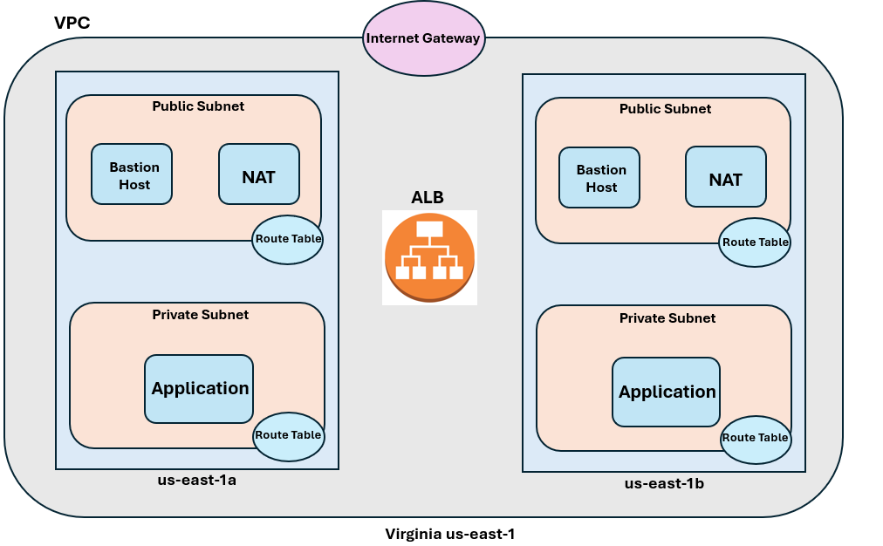

**VPC Creation:**

* Create VPC

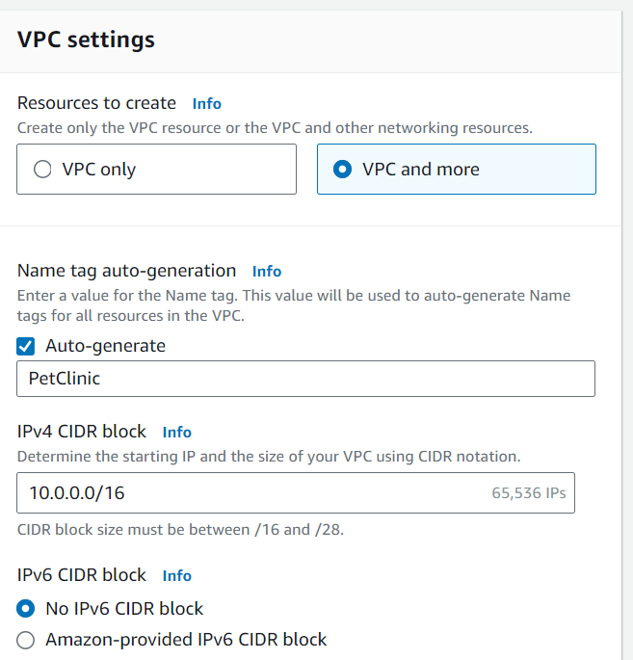

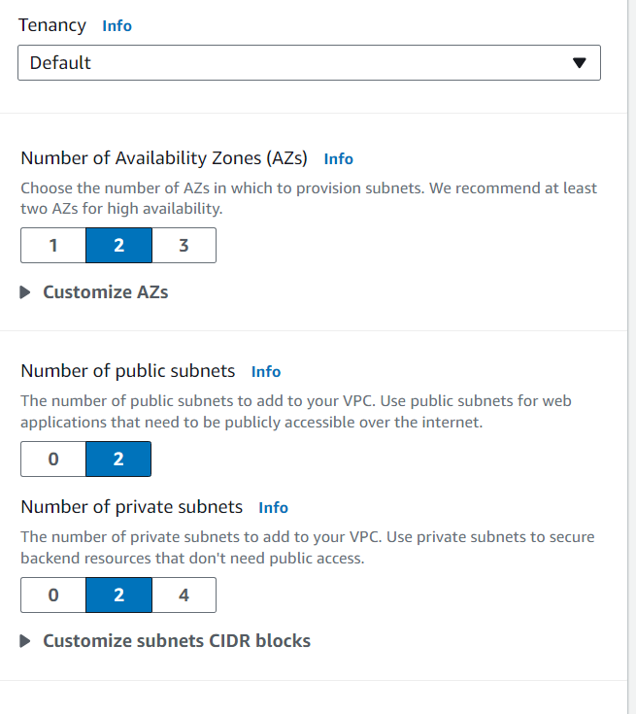

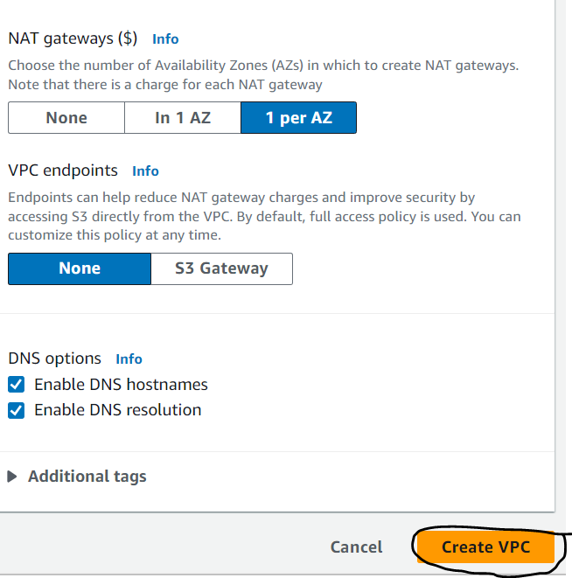

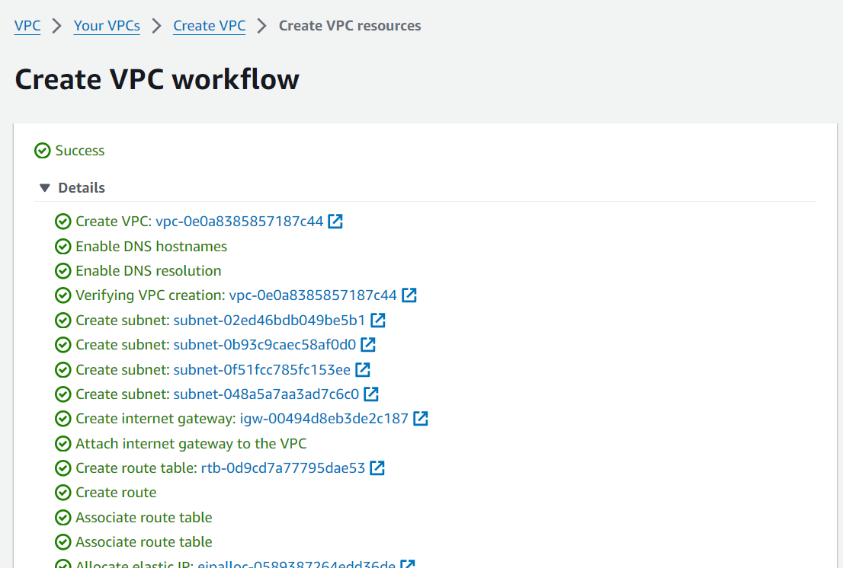

This Sets up our infrastructure according to our requirements as mentioned above in the architecture diagram with all the required path settings on the route tables.

**Create a common Security Group to be used by the launch templates and the load balancer.**

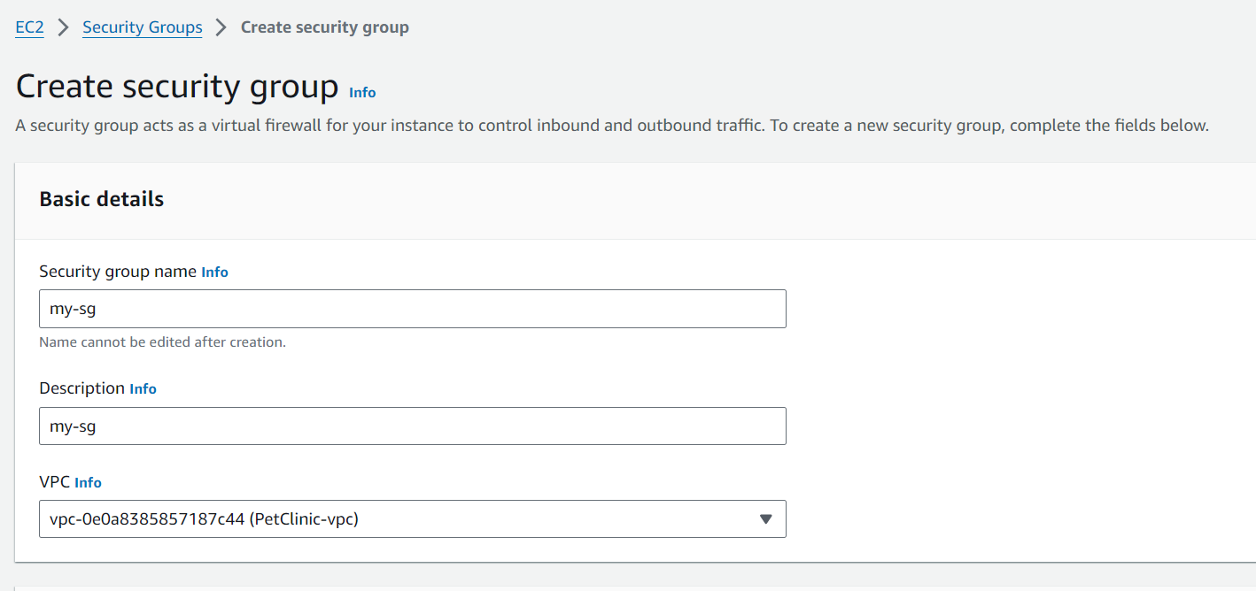

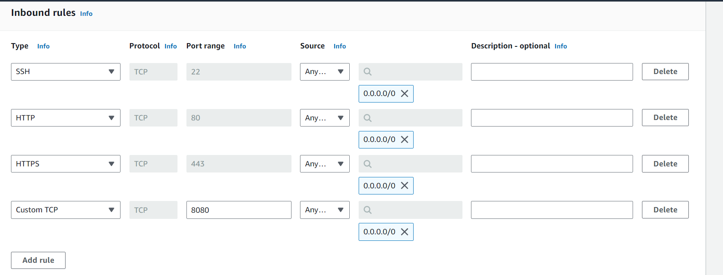

Our application runs on port 8080 so we are opening that port as well.

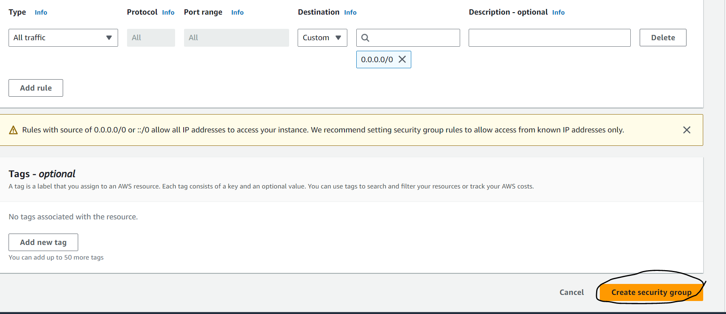

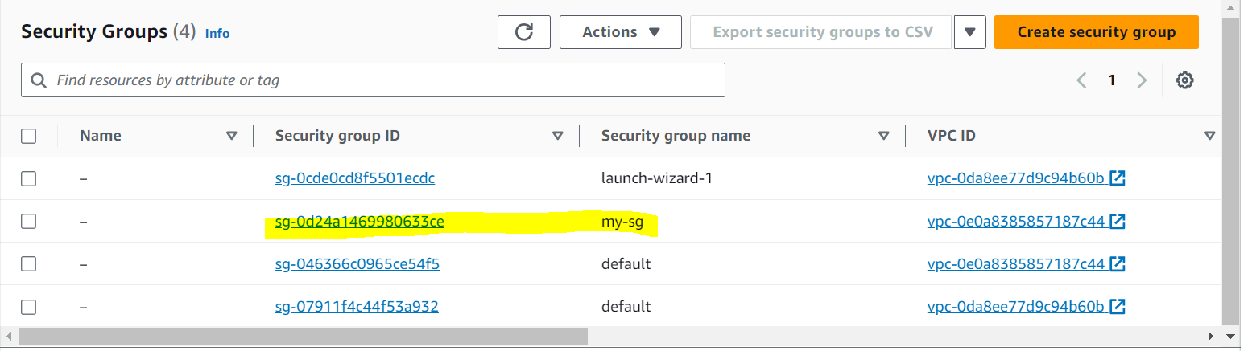

Now we will create a launch template which will be used in the Autoscaling group creation. I will use the userdata script for setting up the instances with a running application. The script actually installs and setup tomcat webserver and fetch a source code from github and uses maven to install and create the package and deploy to tomcat webserver. So once the instances launches our application will be running in the instances. Below is the userdata script used:

#!/bin/bash

#Steps to setup Tomcat Server

apt update

apt install openjdk-11-jre-headless -y

apt install maven -y

cd /opt

sudo wget https://archive.apache.org/dist/tomcat/tomcat-9/v9.0.65/bin/apache-tomcat-9.0.65.tar.gz

sudo tar -xvf apache-tomcat-9.0.65.tar.gz

sed -i 's@/tomcat-users@user username="admin" password="admin1234" roles="admin-gui, manager-gui"/>\n</tomcat-users@g' apache-tomcat-9.0.65/conf/tomcat-users.xml

sed -i 's/<Valve/<!--<Valve/g' apache-tomcat-9.0.65/webapps/manager/META-INF/context.xml

sed -i 's/<Valve/<!--<Valve/g' apache-tomcat-9.0.65/webapps/host-manager/META-INF/context.xml

sed -i 's/<Manager/--><Manager/g' apache-tomcat-9.0.65/webapps/manager/META-INF/context.xml

sed -i 's/<Manager/--><Manager/g' apache-tomcat-9.0.65/webapps/host-manager/META-INF/context.xml

sh apache-tomcat-9.0.65/bin/startup.sh

##Steps to create jar/war

git clone https://github.com/vijeshnair89/Petclinic.git

cd Petclinic

mvn clean install

cp /opt/Petclinic/target/petclinic.war /opt/apache-tomcat-9.0.65/webapps/petclinic.war

**Launch Template Creation:**

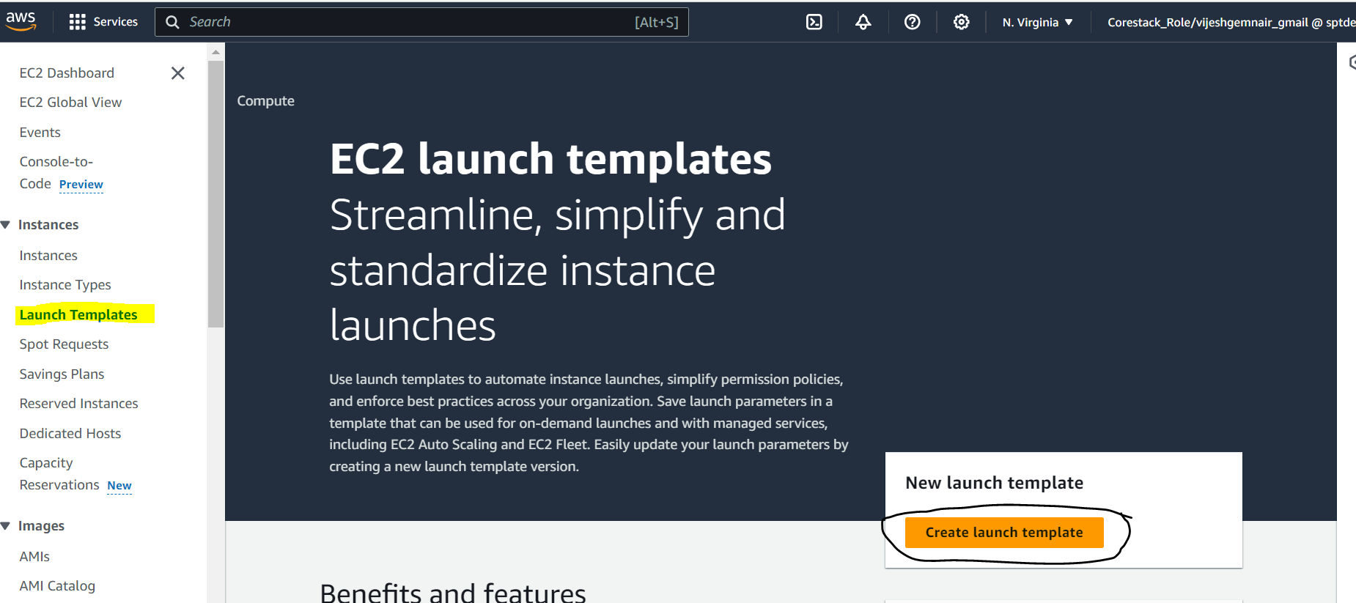

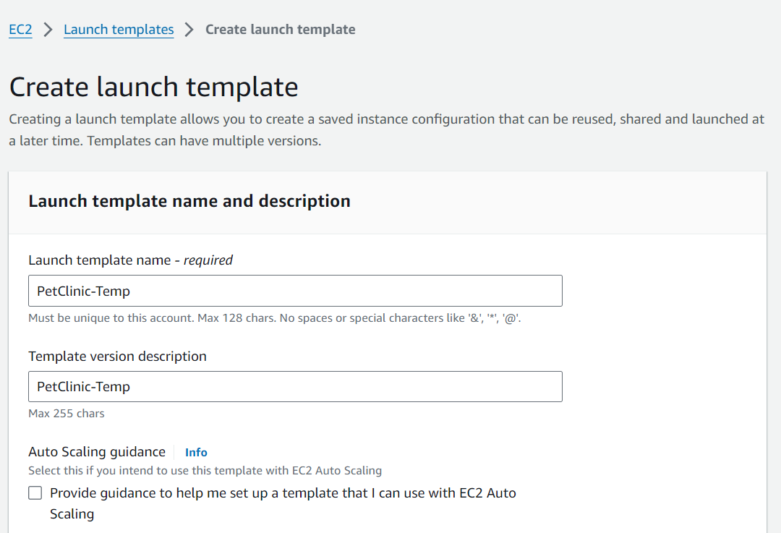

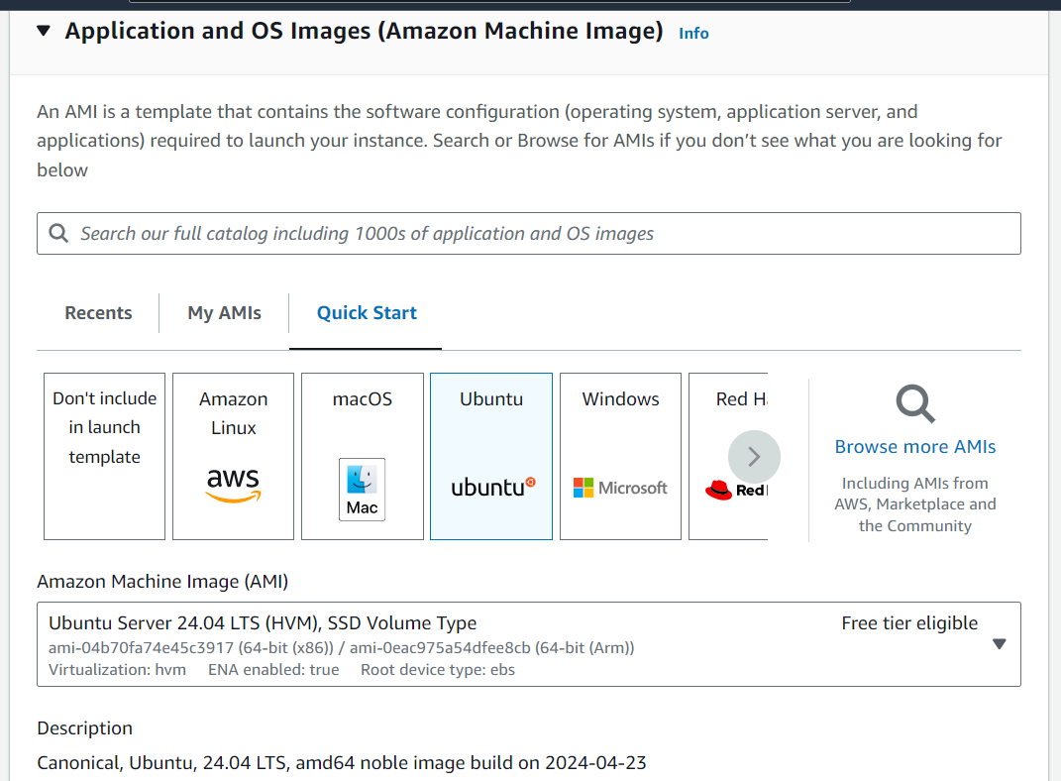

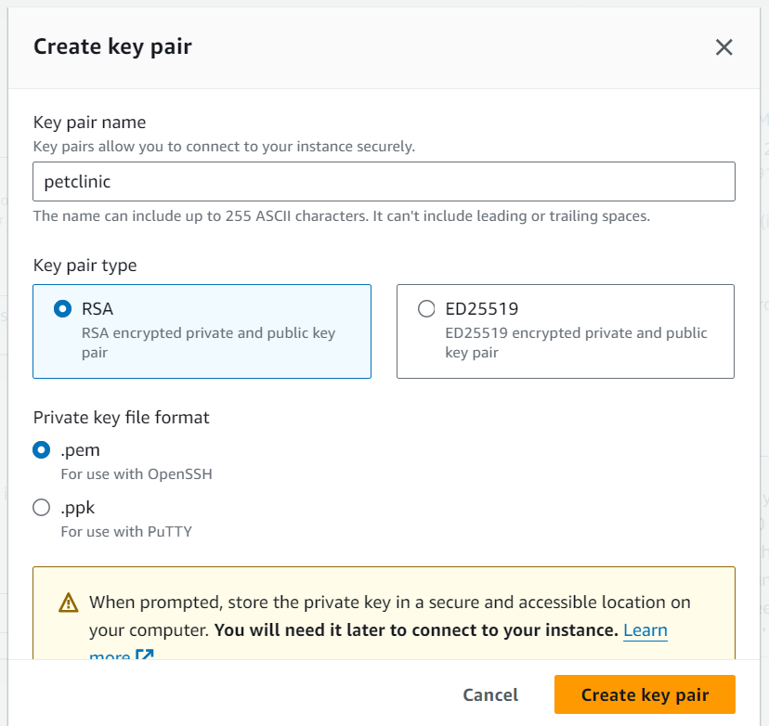

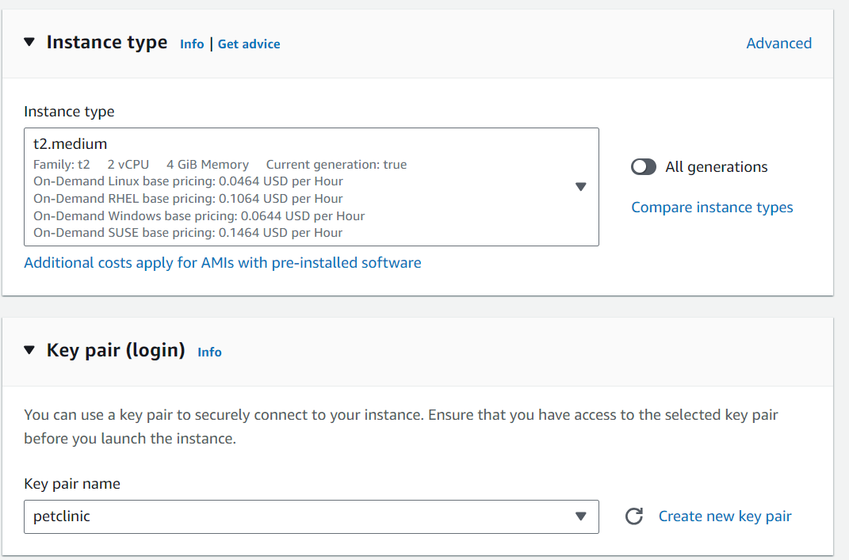

Under network settings just create a security group and setup ssh, http and https.

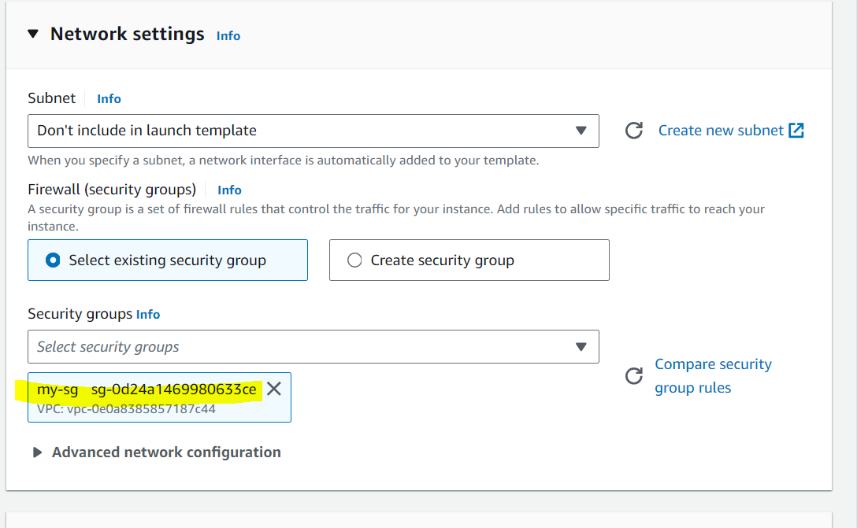

Next in the advanced details section add the script in the userdata and click on launch template.

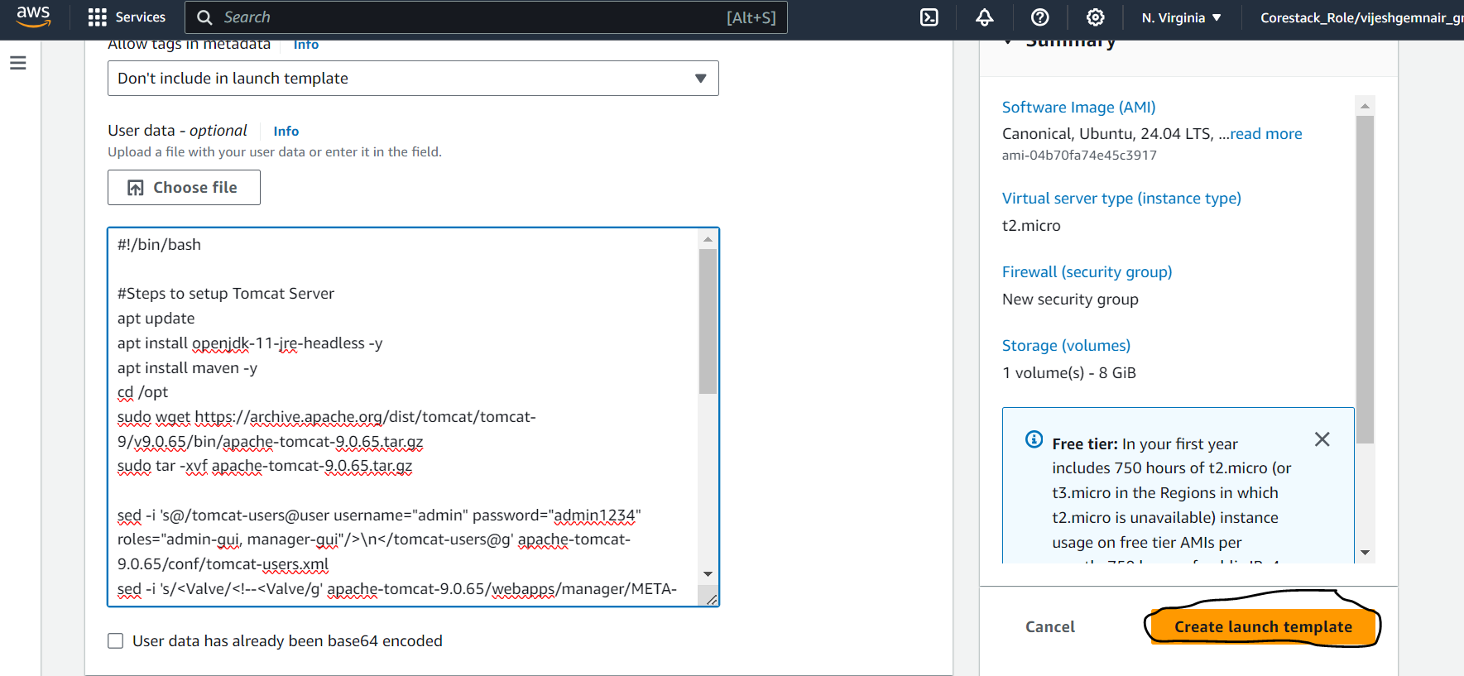

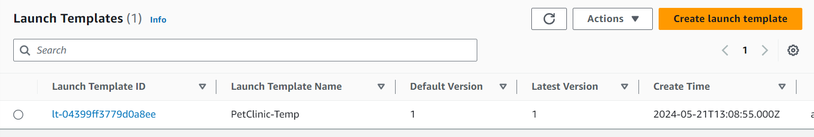

Now lets create an application load balancer which we will then attach to the Autoscaling Group later. Before creating load balancer lets create target group and then will attach to the load balancer.

**Target Groups Creation:**

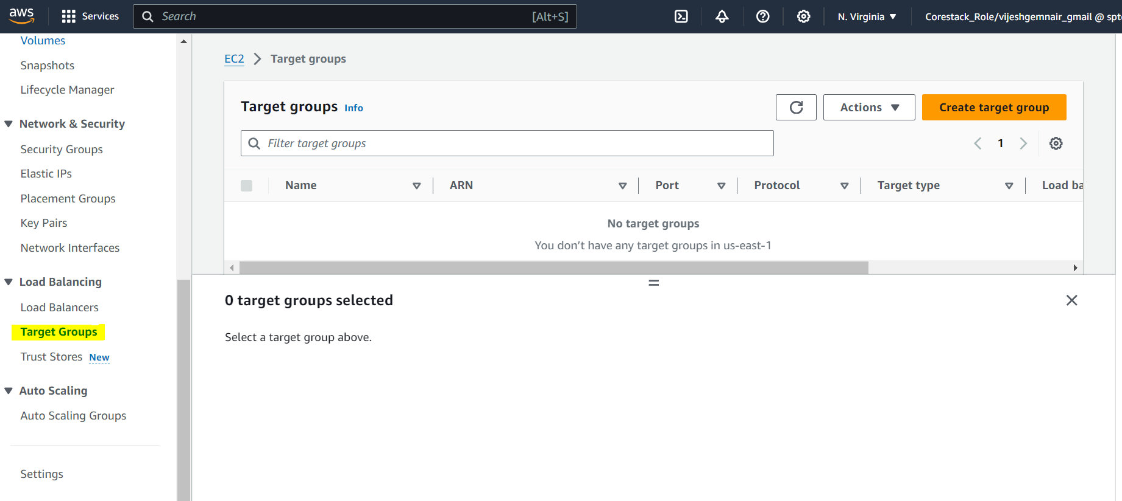

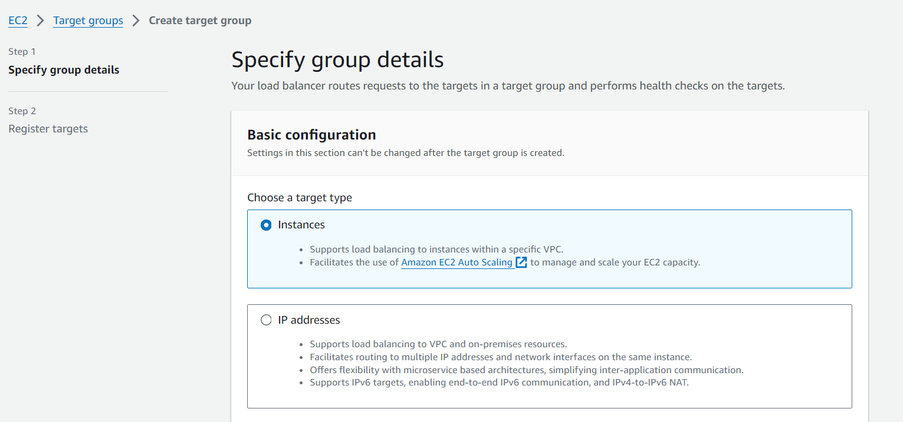

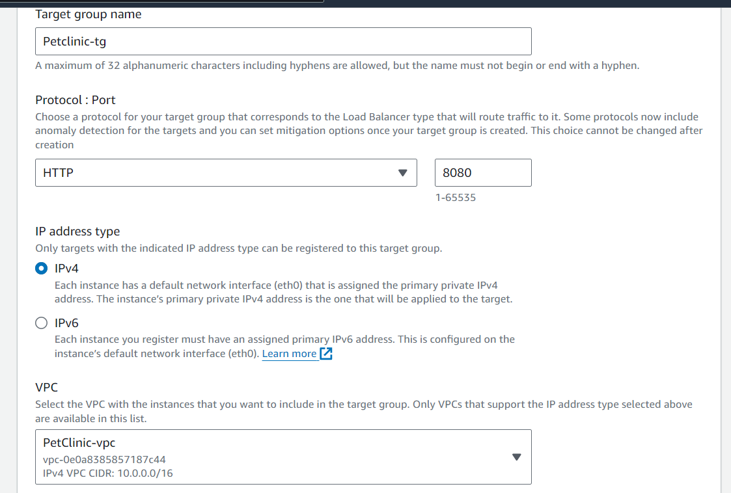

Since our application runs on tomcat webserver which can be accessed on port 8080 so we give the port as 8080.

In the advanced health check settings change the unhealthy threshold as 5 which means it will try to hit the server 5 times on the port before declaring it as unhealthy.

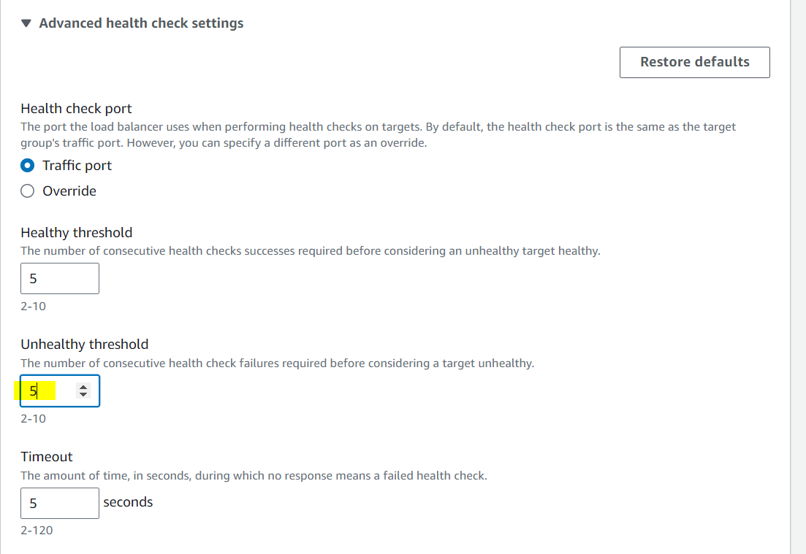

Keep all the other settings as default and create the target group.

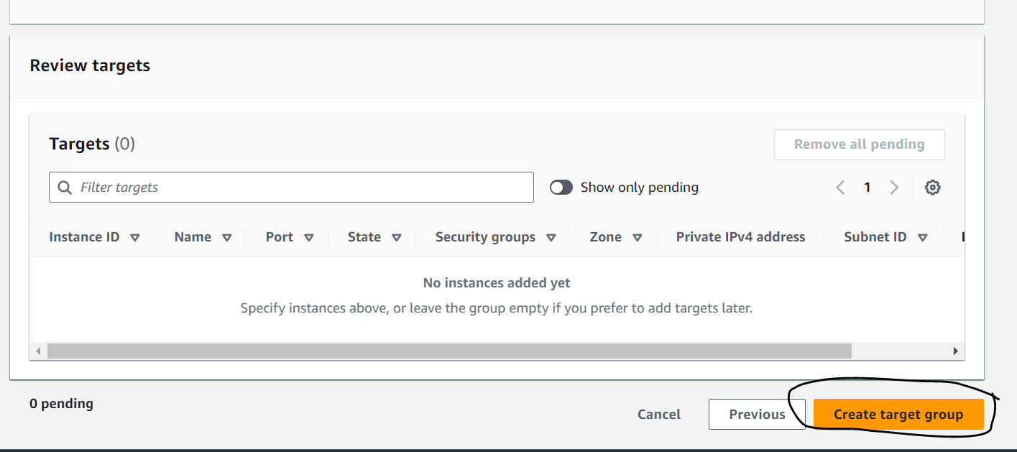

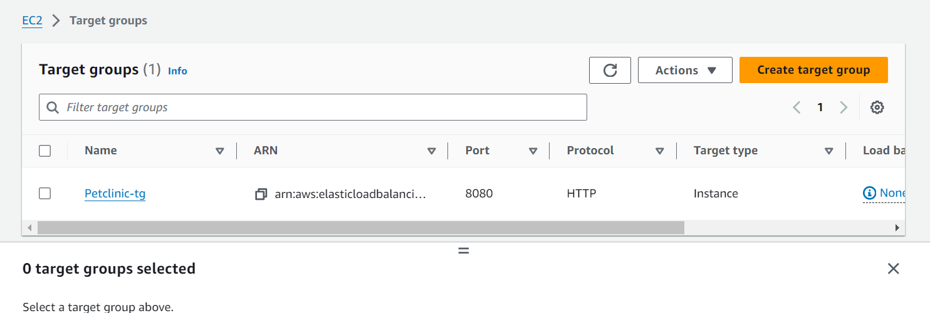

**ALB Creation:**

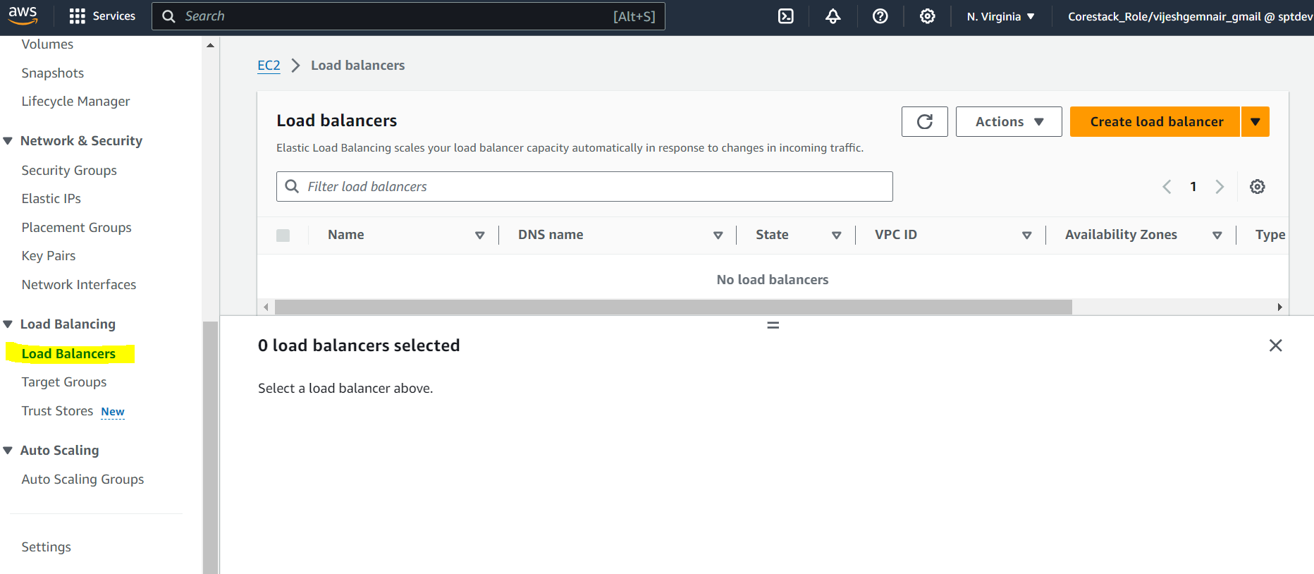

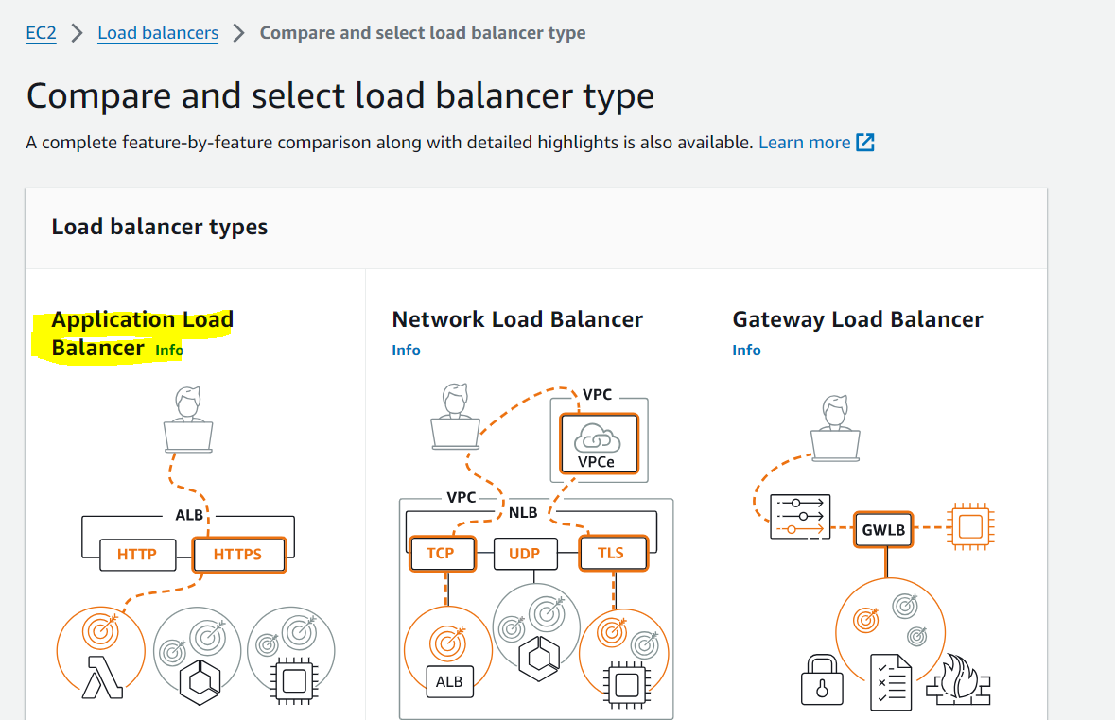

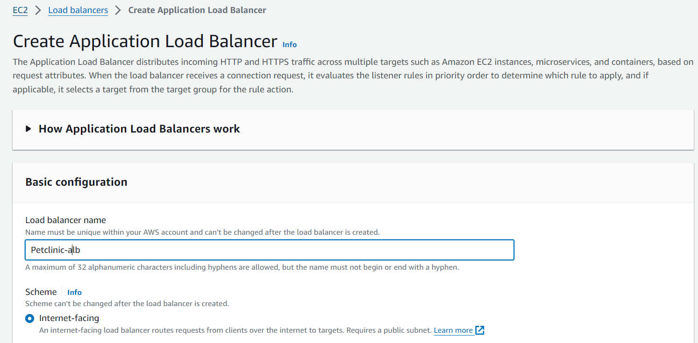

Load balancer should be in the public subnet under the VPC.

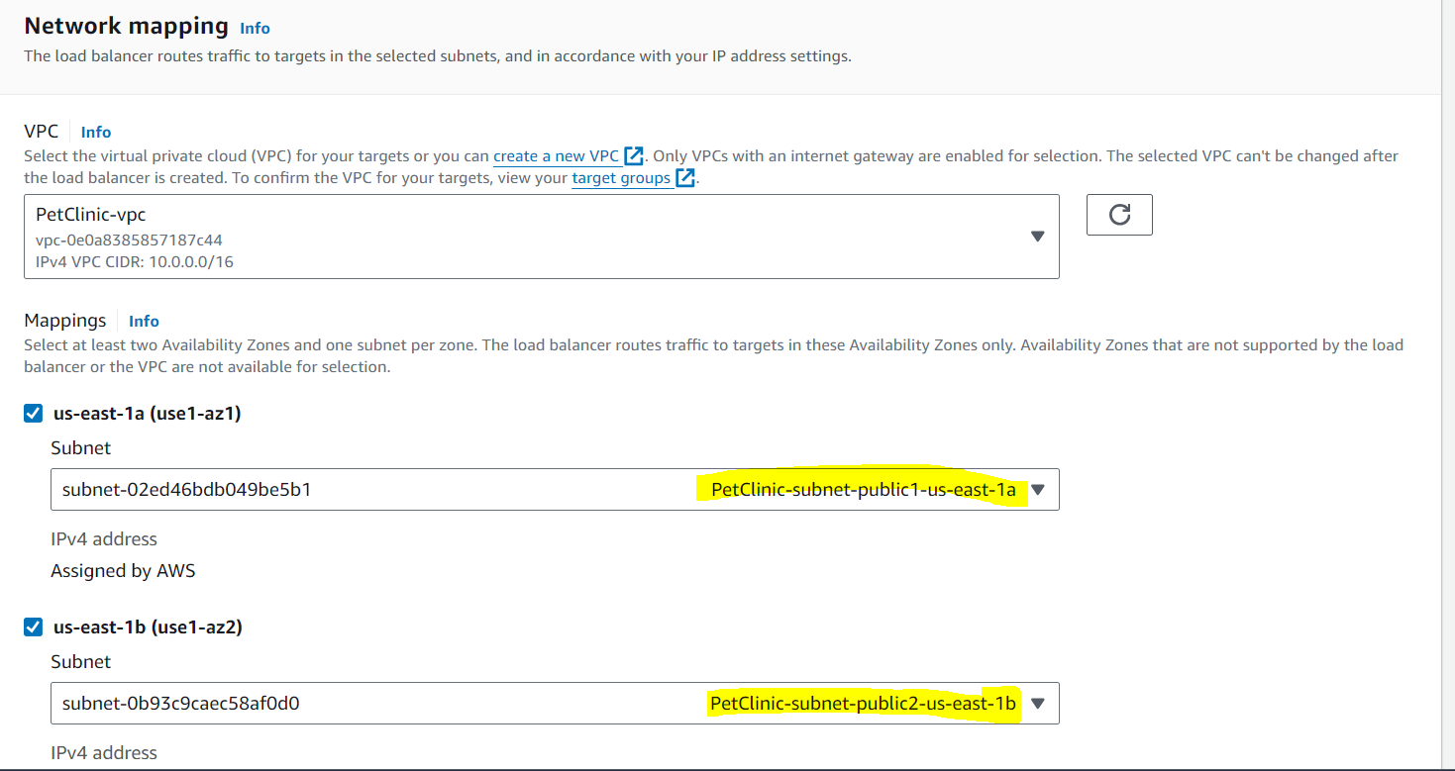

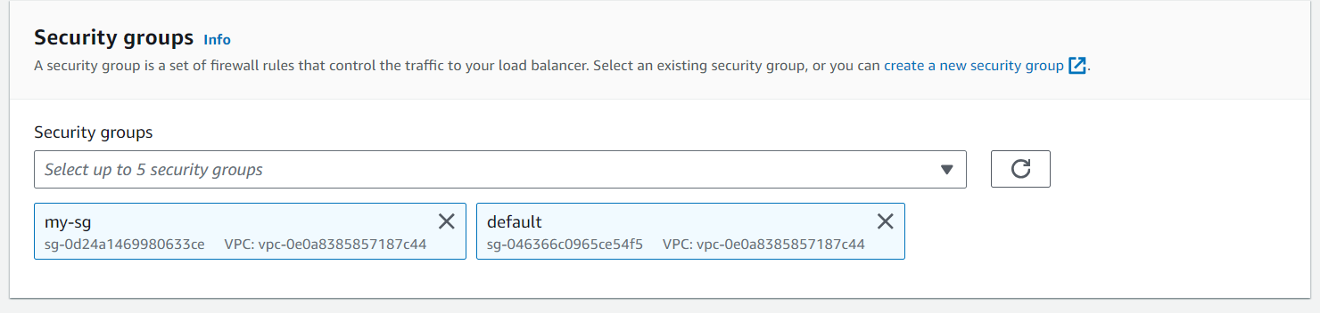

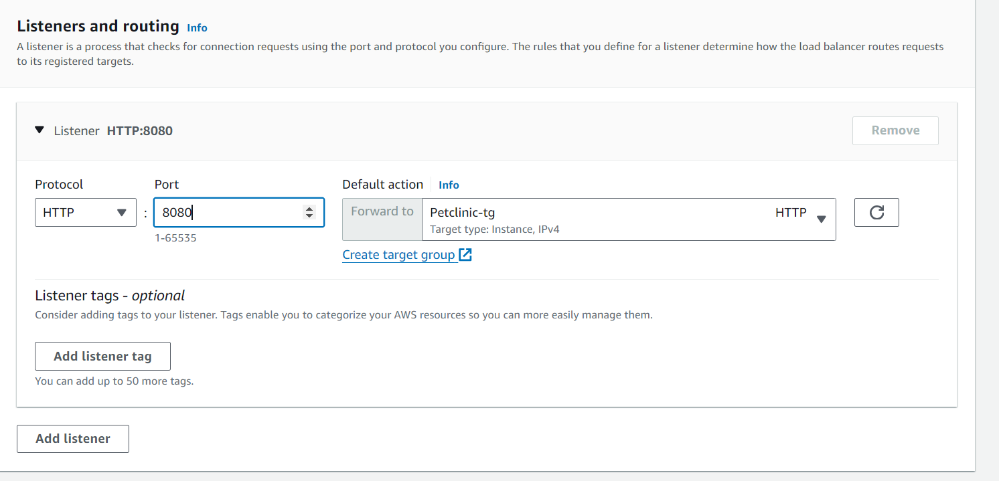

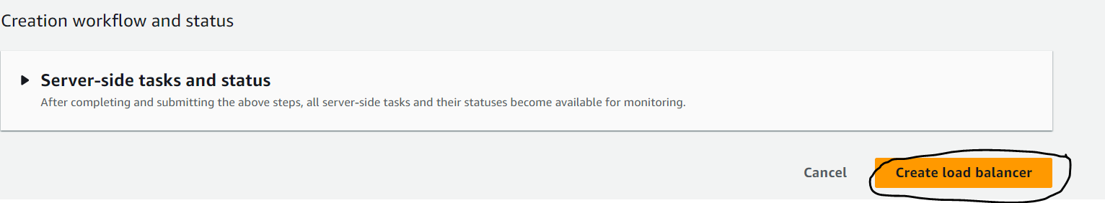

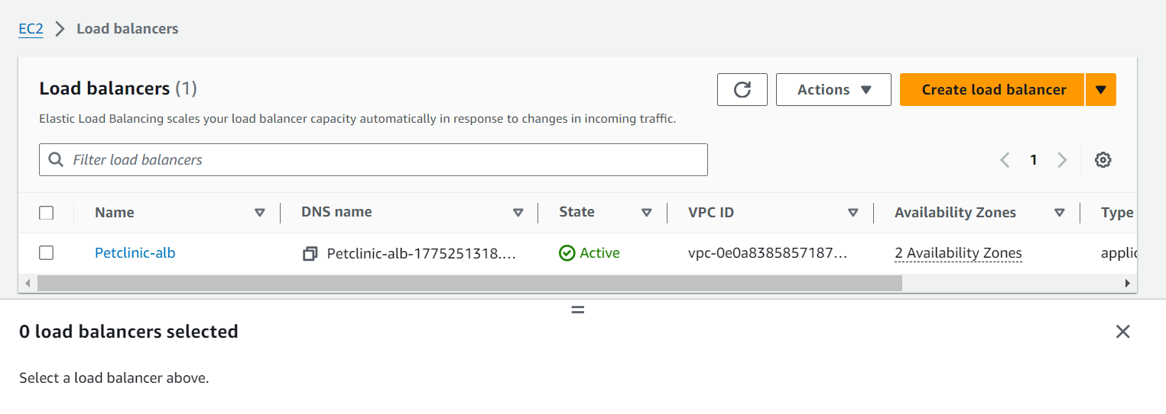

**Autoscaling Group Creation:**

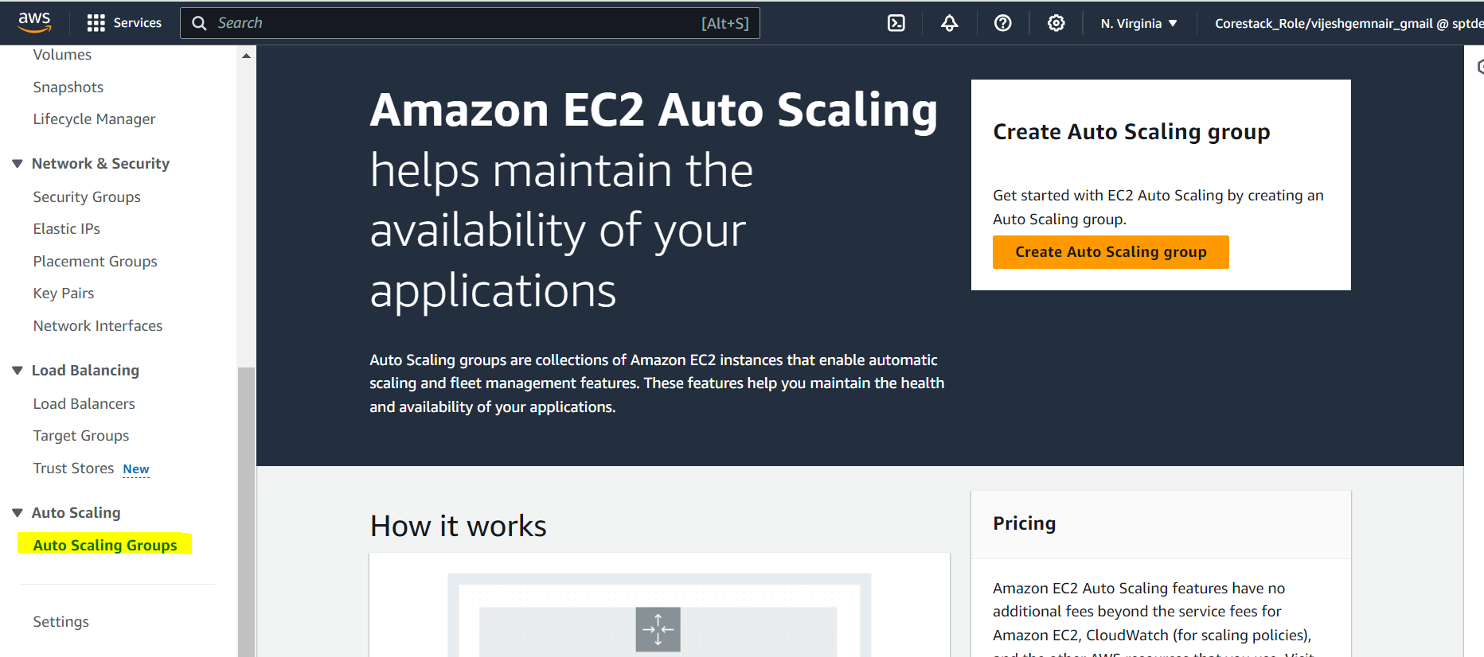

Select the launch template we created earlier:

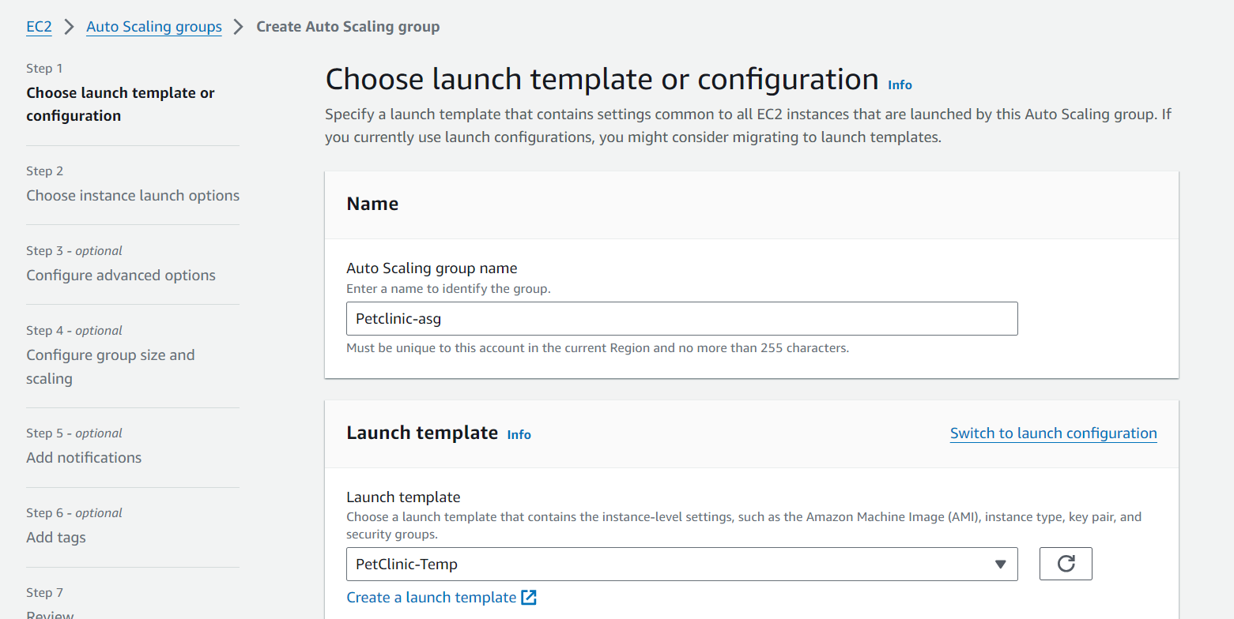

Click Next

Since we want our application to be in the private subnet hence we have to select private subnets within the VPC, where our application will launch.

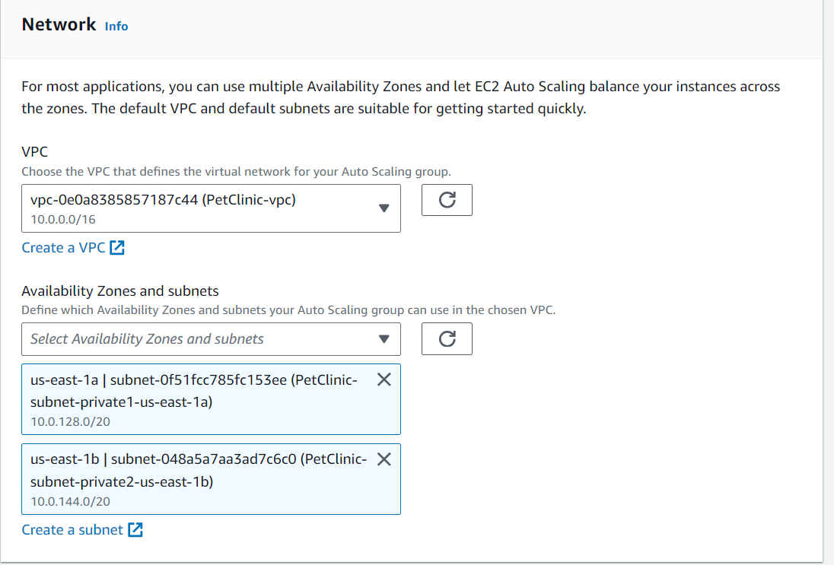

Click Next

Attach to the load balancer:

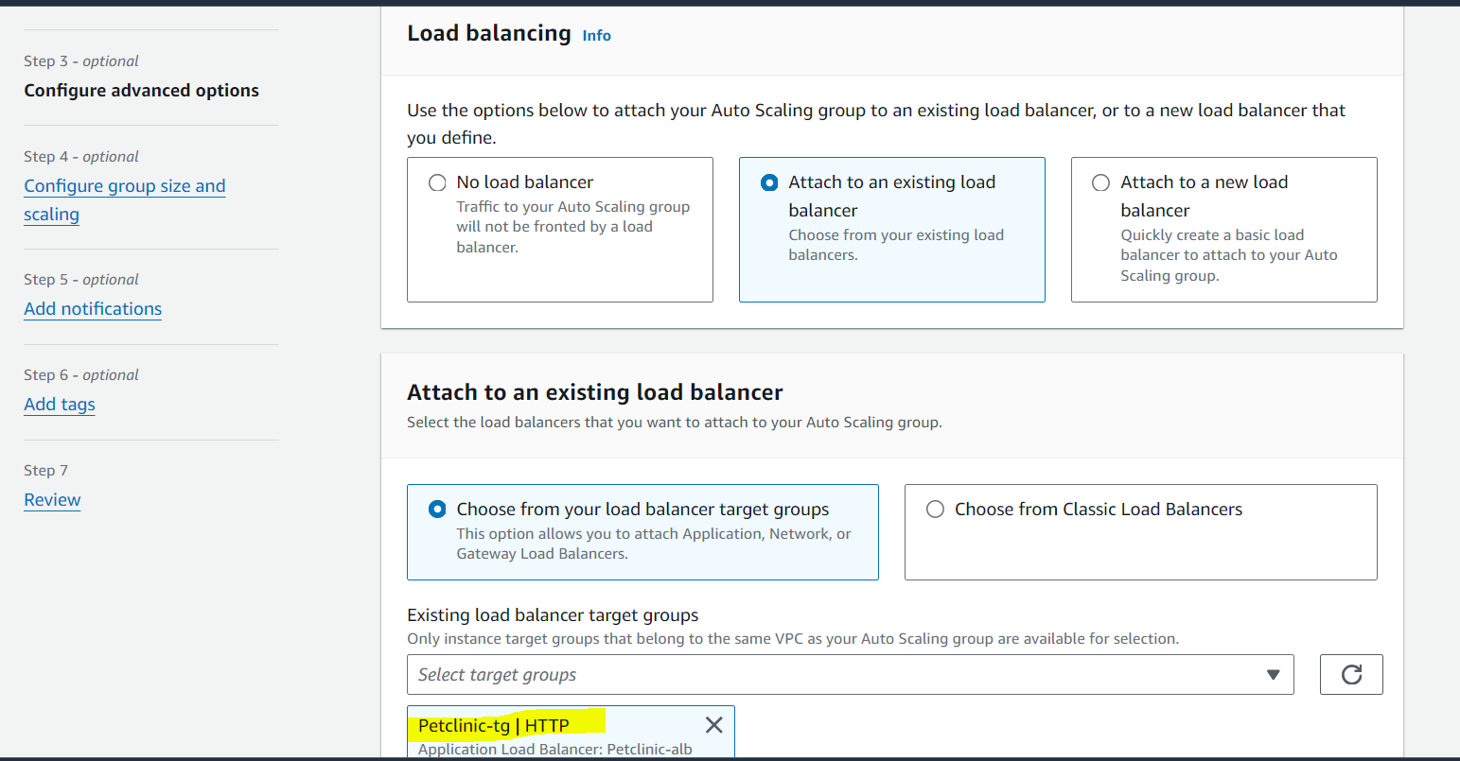

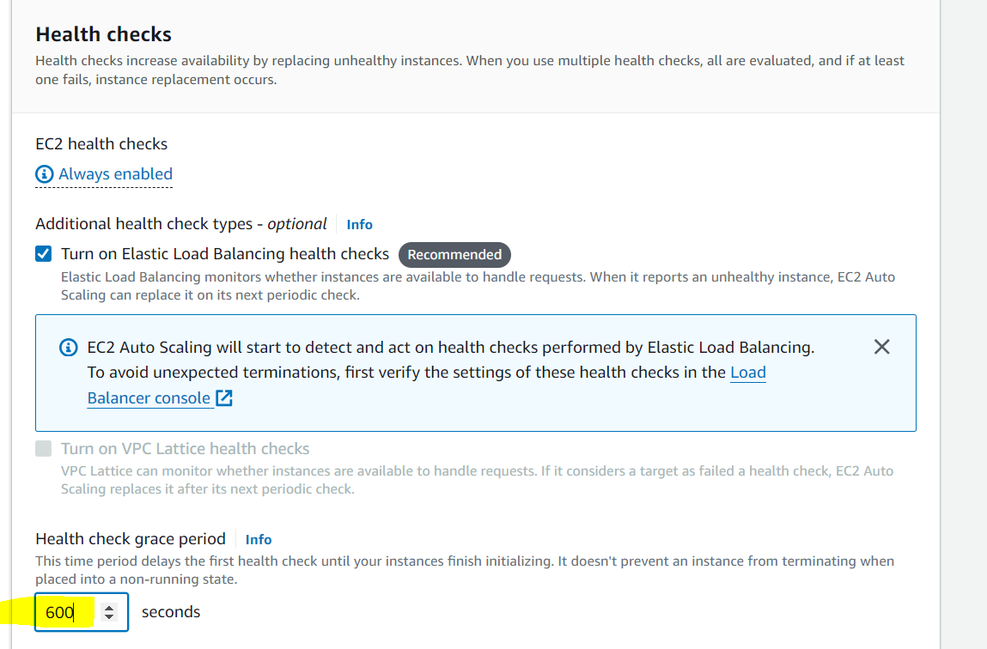

Health check grace period we can increase to 600sec as our instance can require some time to complete initialization as there are application scripts running while initializing and after the initialization is complete then only the health check starts else the system will be declared as unhealthy without even loading the application which is a wrong prediction.

Group size defines the desired , maximum and minimum instances which should be created in a default , upscaling and downscaling scenarios respectively.

Desired: 2

Minimum: 2

Maximum: 4

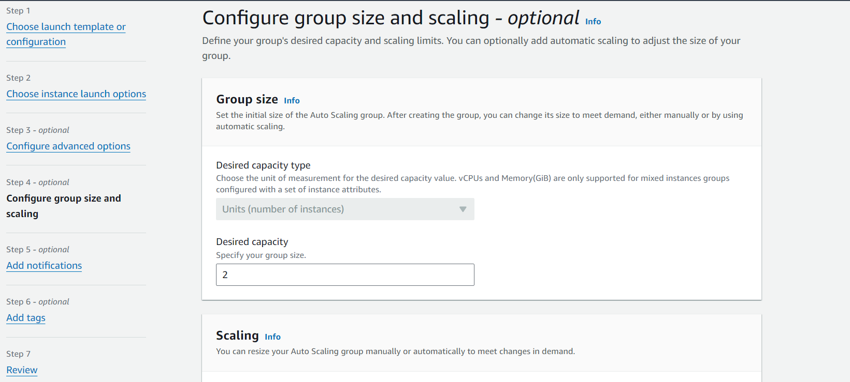

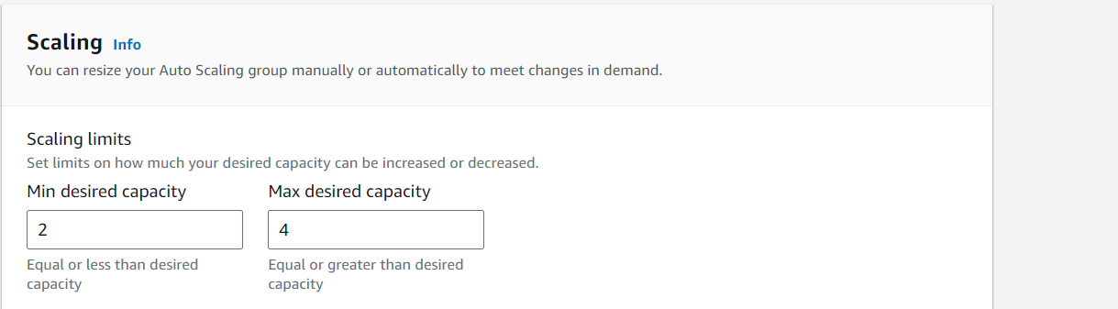

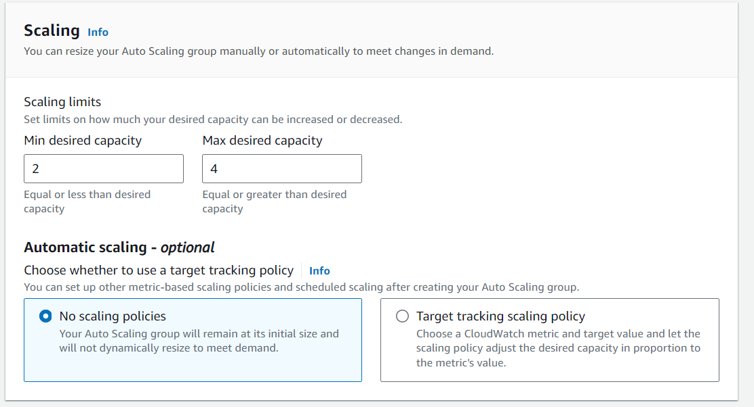

We will create a simple scaling policy and create cloudwatch alarms once the ASG is created.

Click next

We will create a SNS notification which will notify through mail whenever any instances are removed or added as a process of autoscaling.

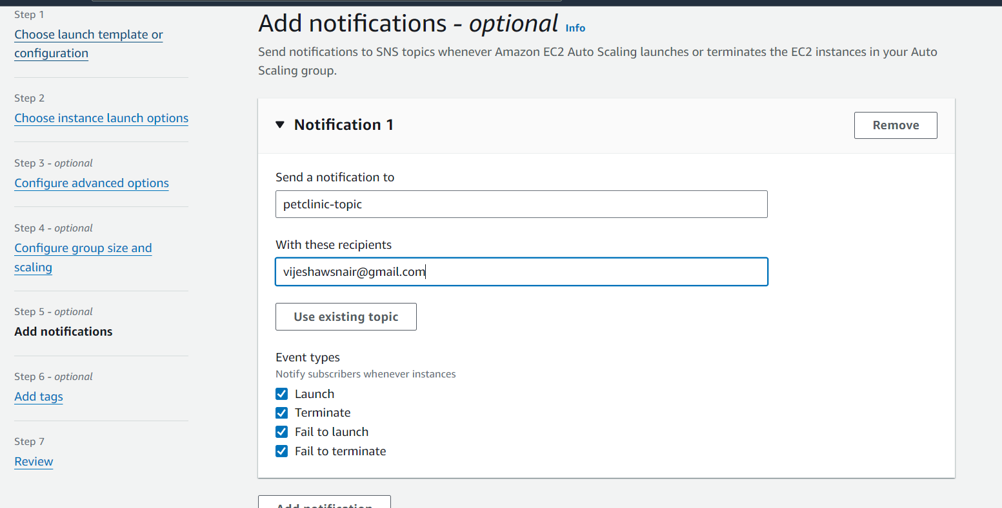

Next keep everything default and review and create the ASG.

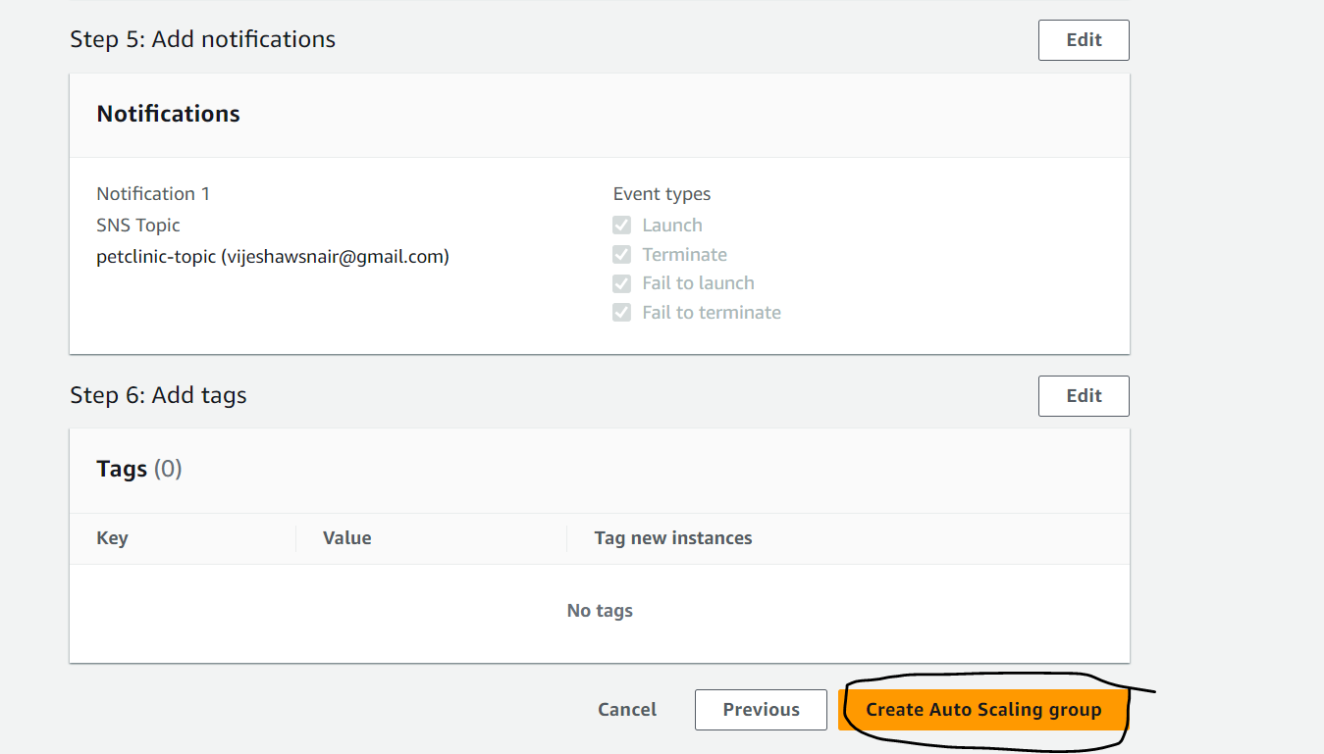

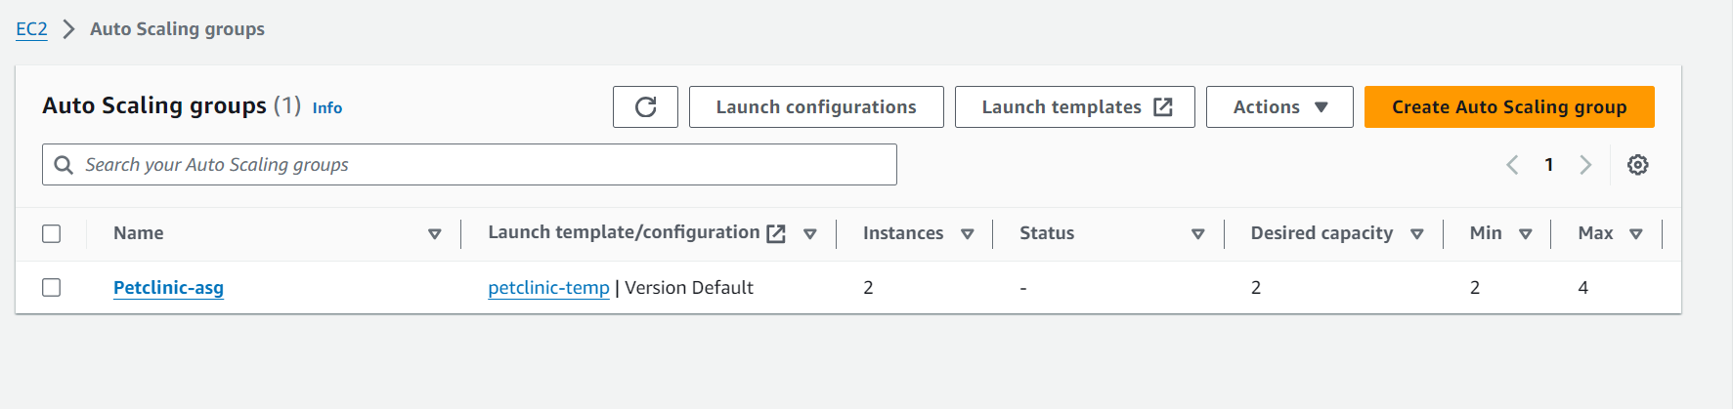

Here we have to do one thing once we create a SNS notify we will get a mail in our mentioned mailid where we need to go and manually confirm as below:

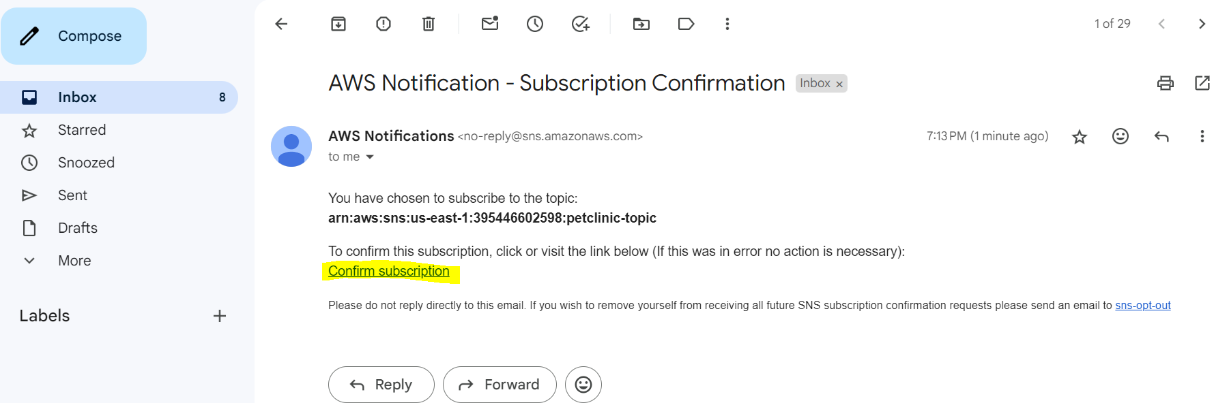

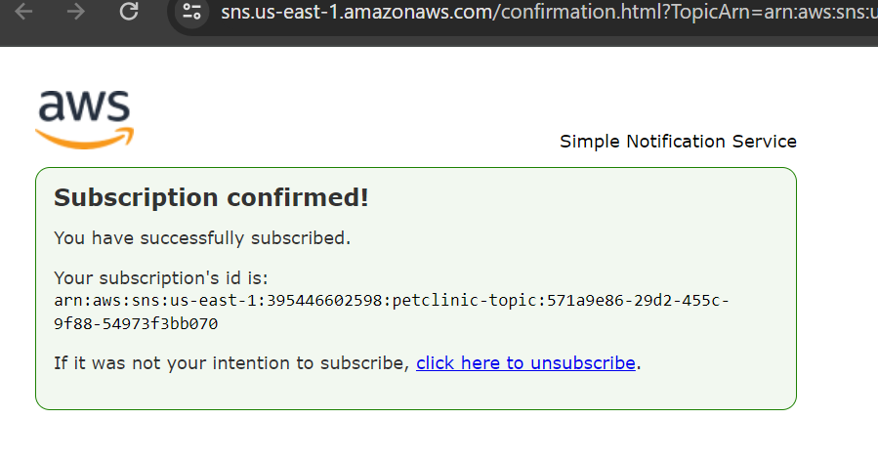

After the ASG is created , the instances will create and will get registered under the target group we created earlier:

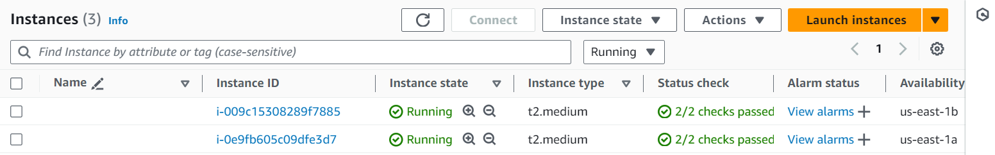

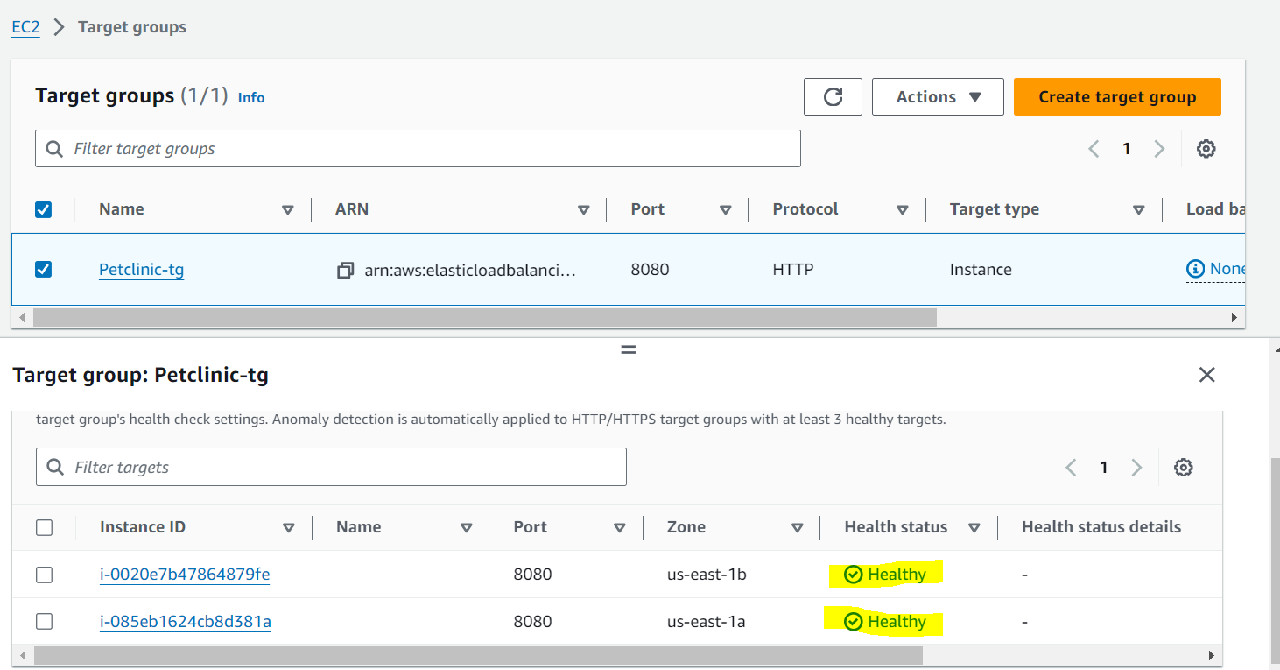

**Now lets create a scaling policy for ASG:**

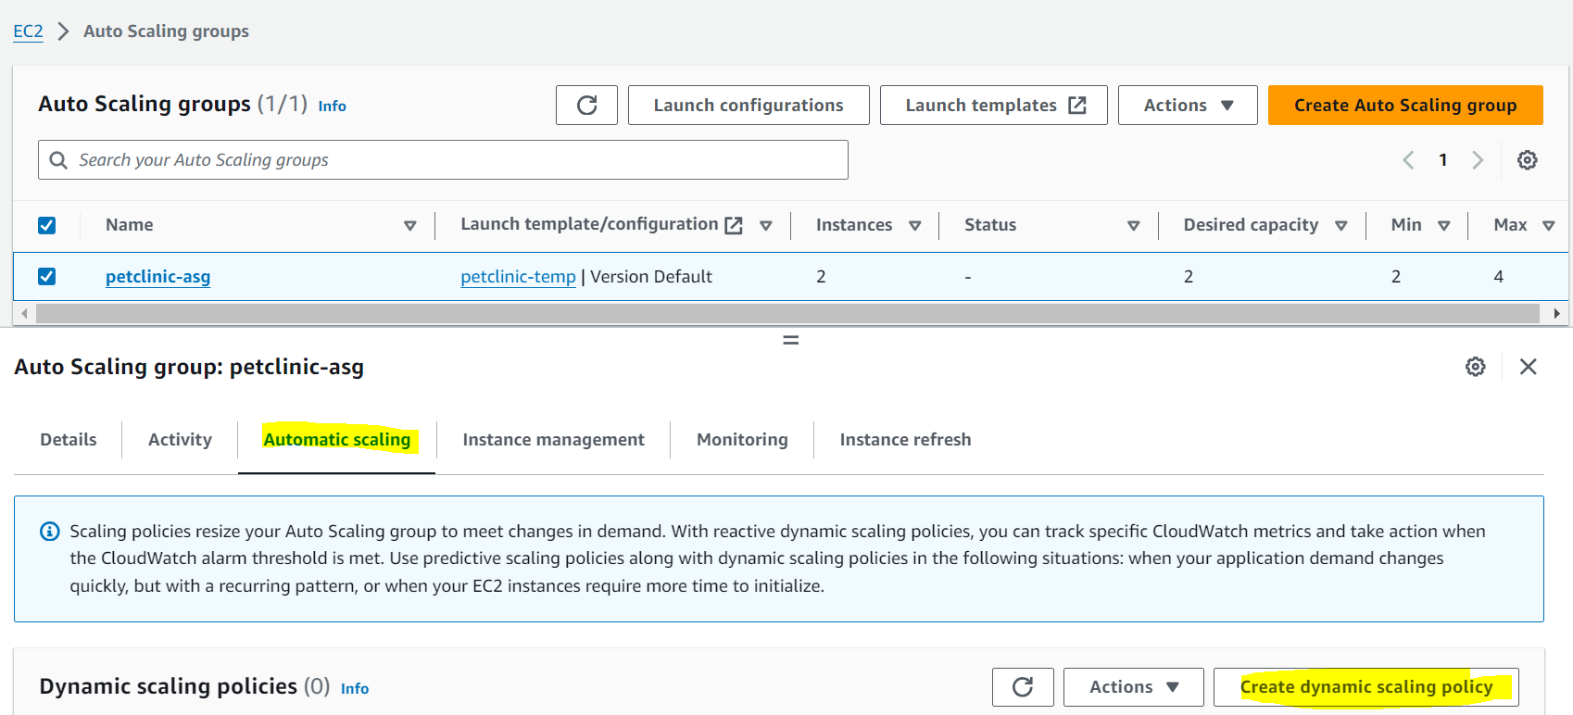

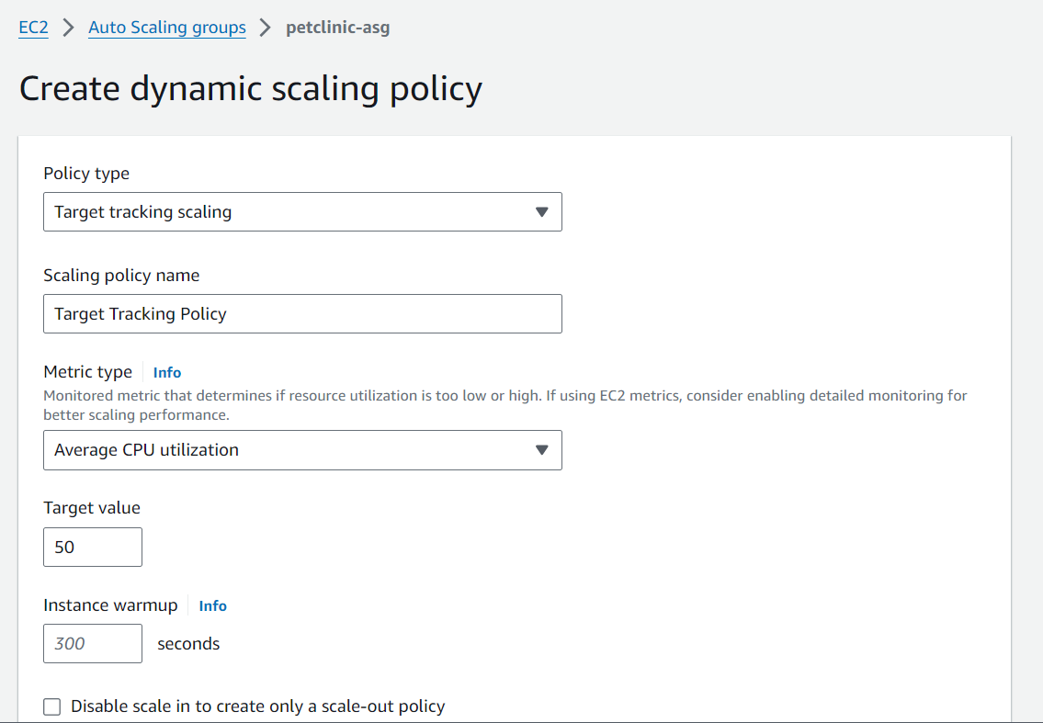

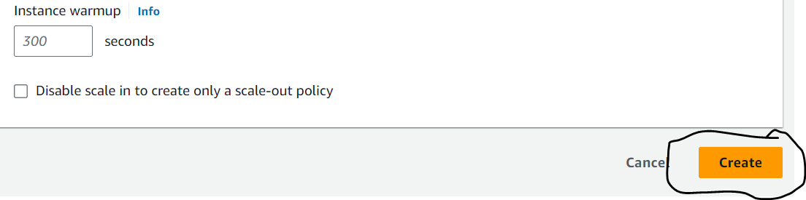

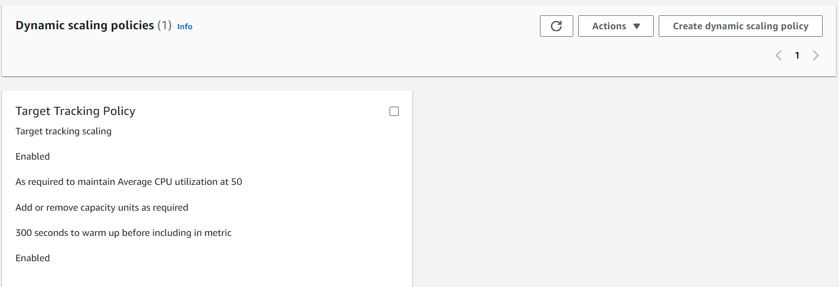

Now go to cloudwatch, we can see 2 alarms created:

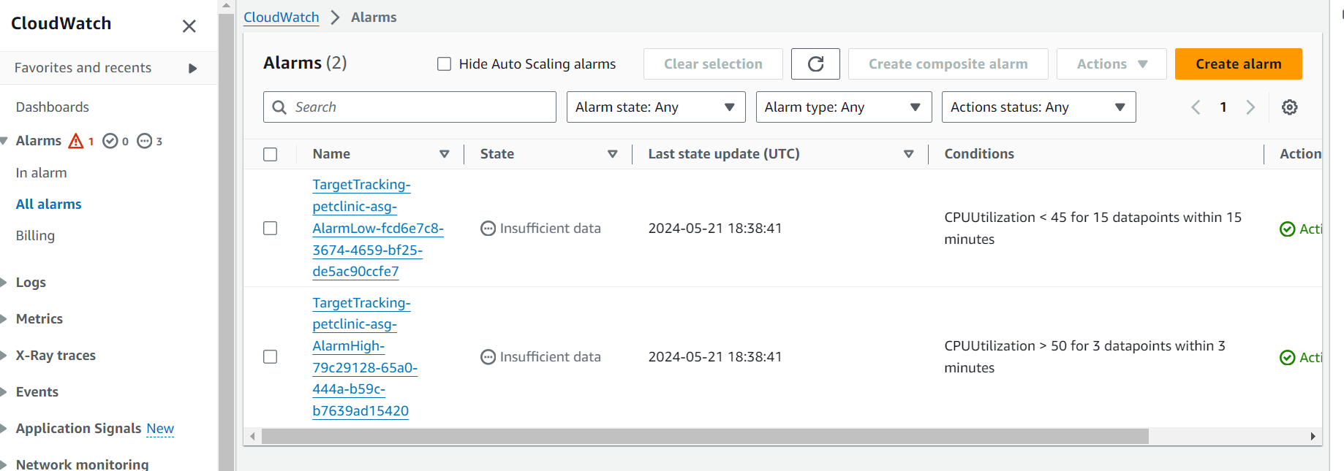

**Create a bastion host so that if we need to get into our private instances within the VPC we can do through the bastion host.**

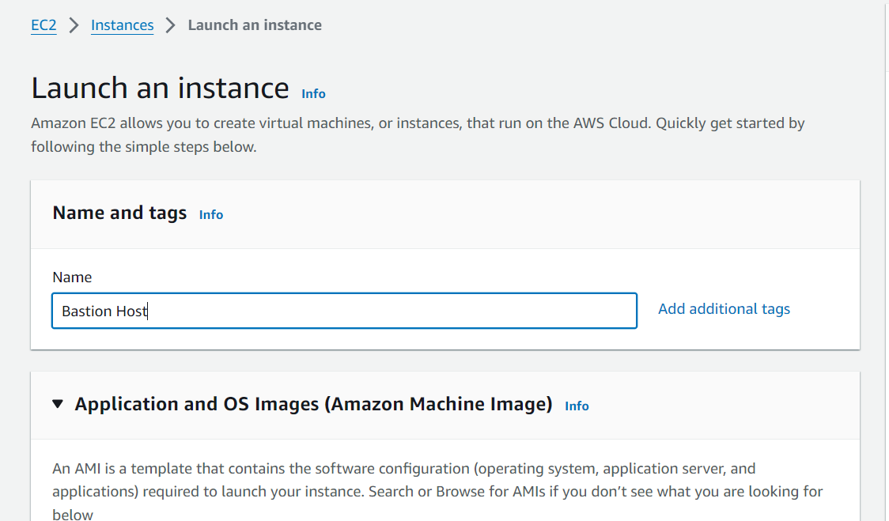

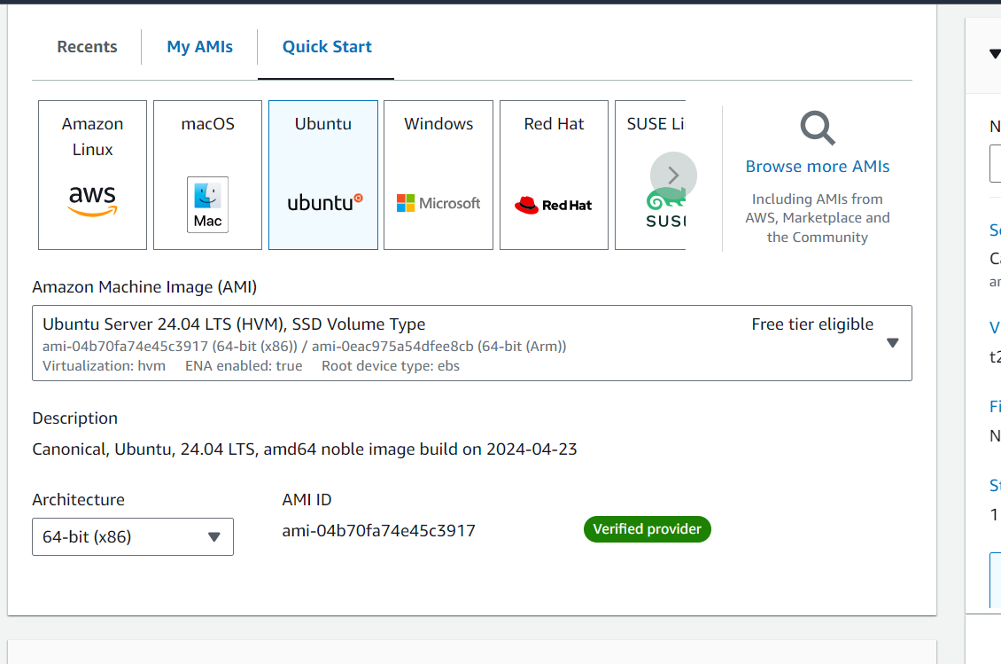

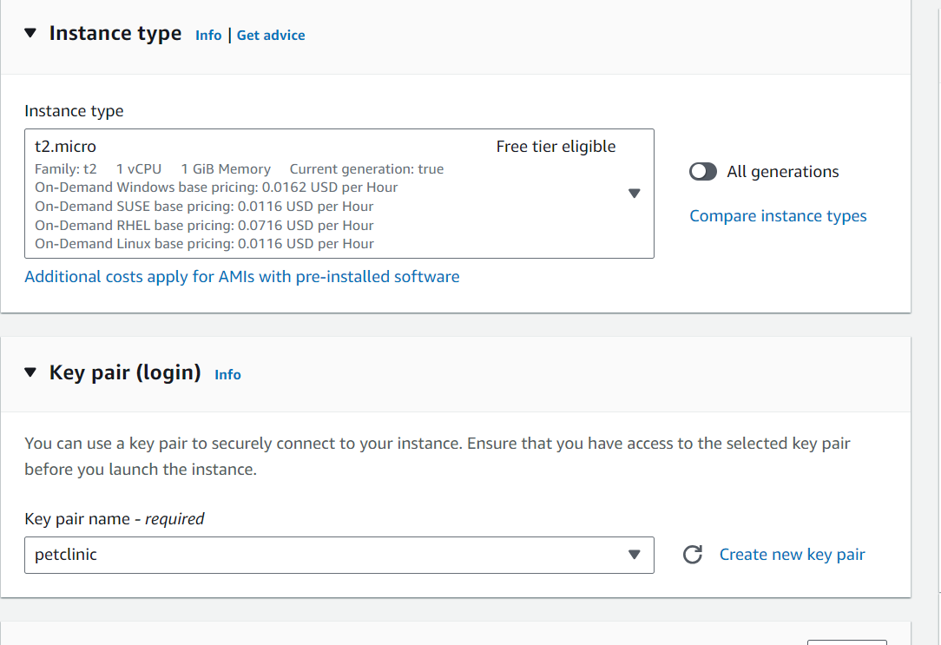

Make surre the bastion host should be within our VPC:

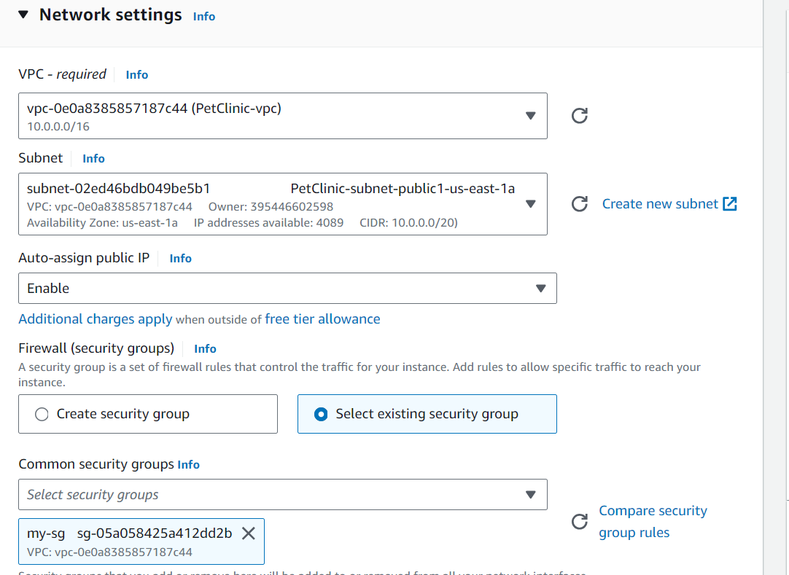

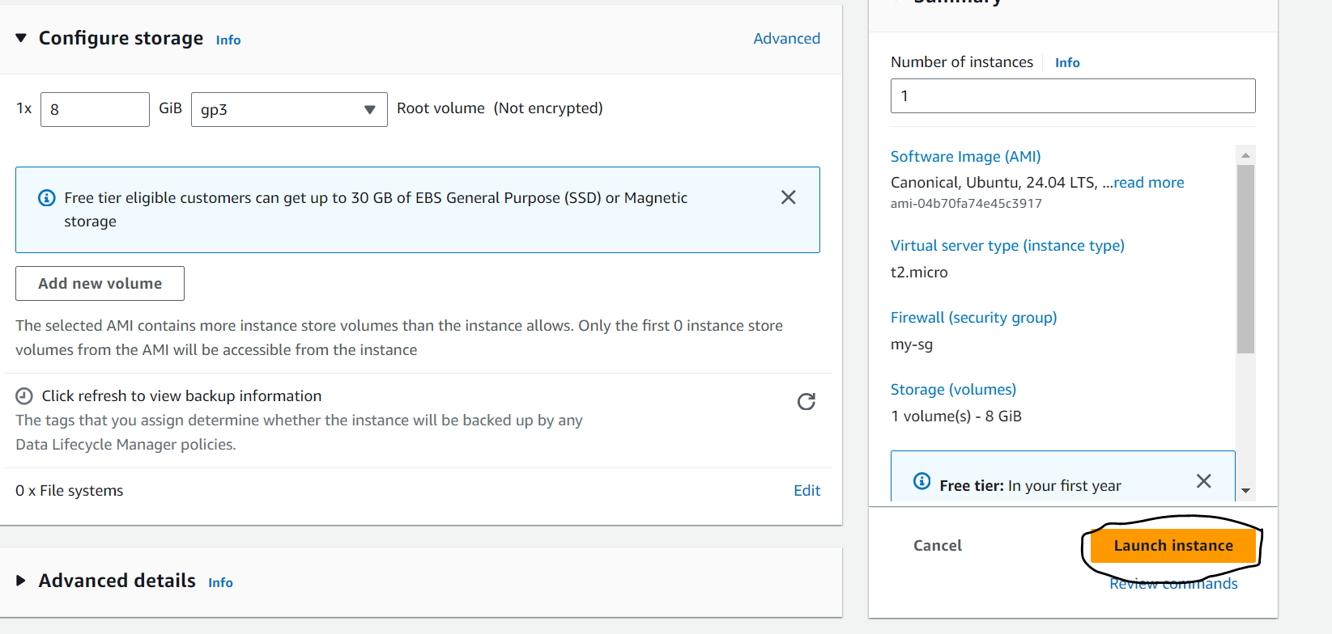

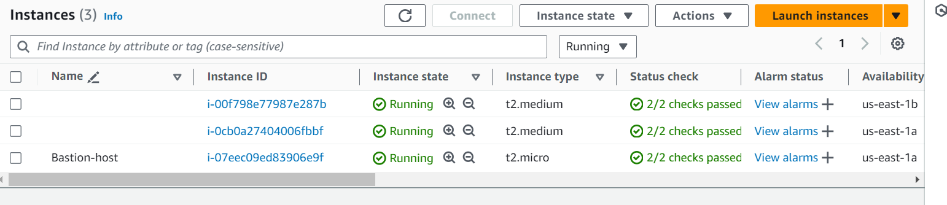

Now use the loadbalancer DNS and browse using port 8080 and context /petclinic to view the application:

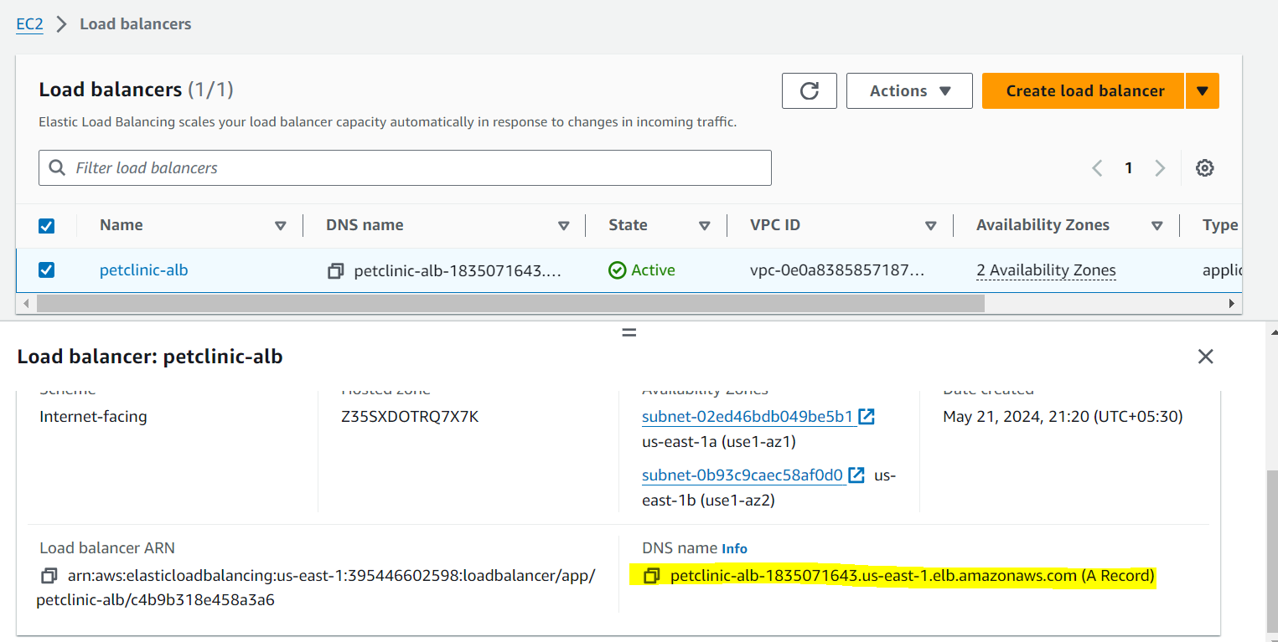

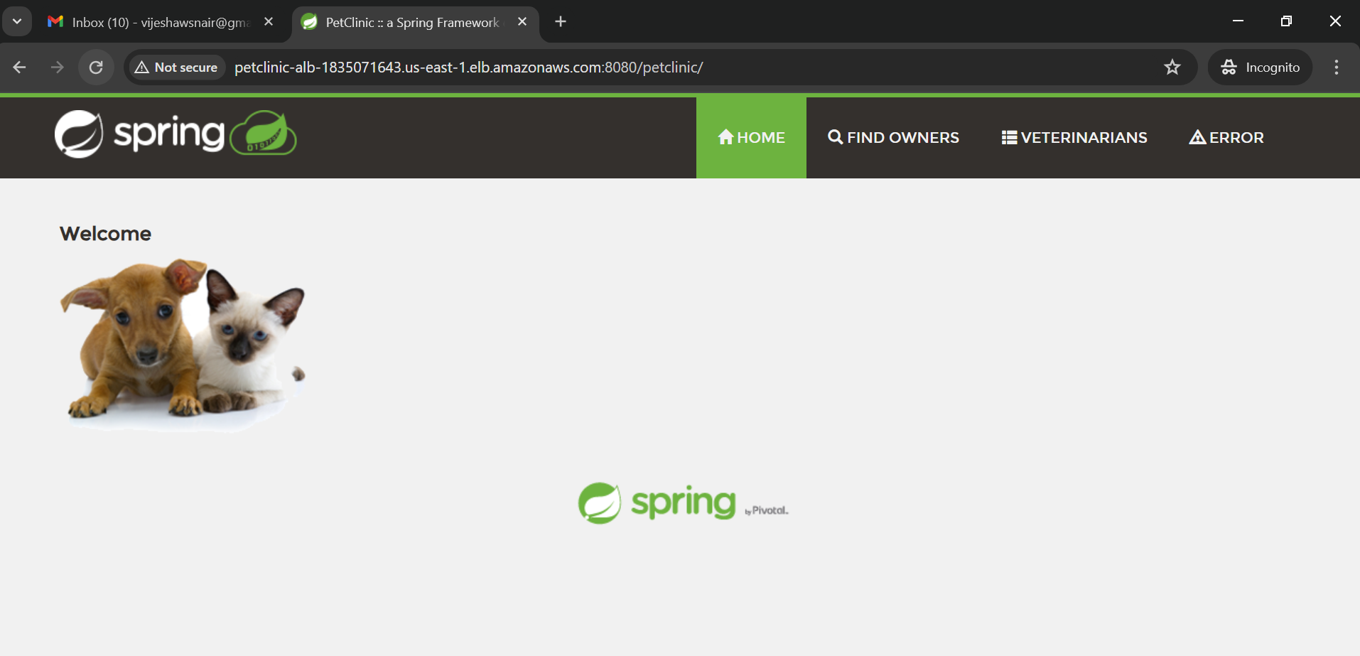

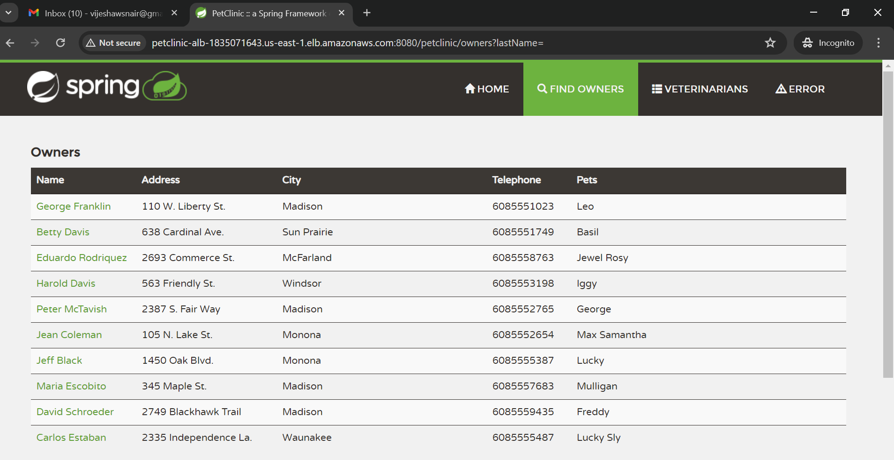

**Next we will see the autoscaling feature by using 2 scenarios:**

First we will manually stop one application server then the load balancer will treat it as unhealthy and an instance will be triggered to maintain the desired state.

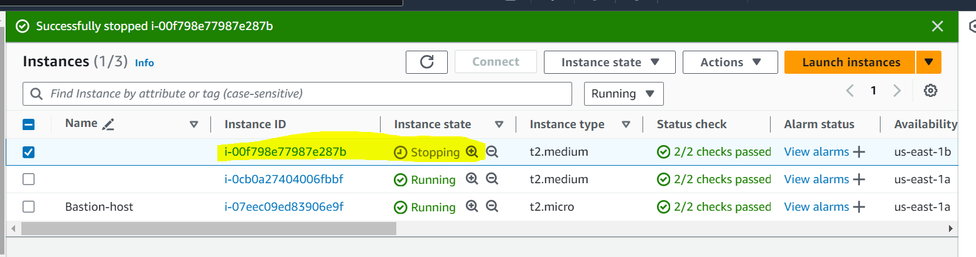

The above instance becomes unhealthy and a new instance is launched by ASG. The unhealthy instance will be drained and removed from the target group.

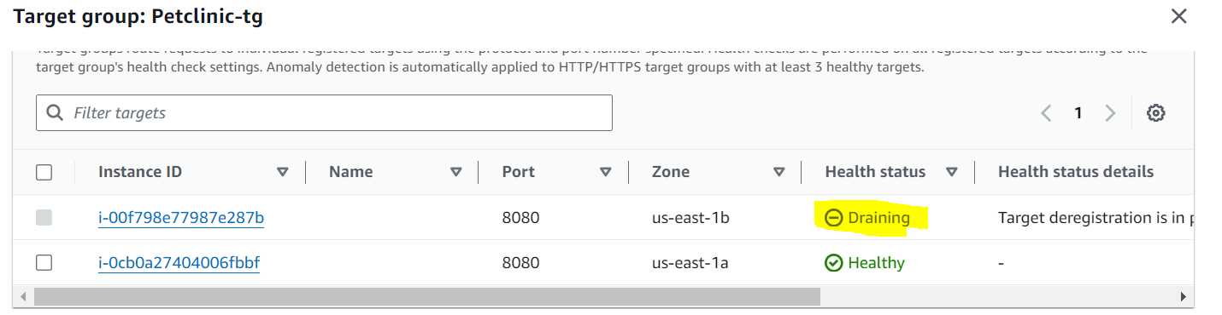

A new instance will be launched as below:

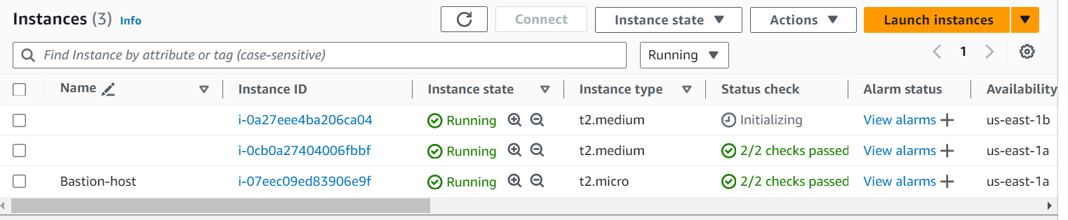

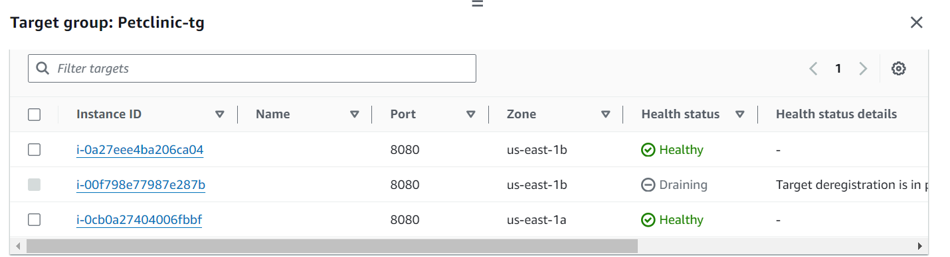

**Second** , lets login to one of the application server and manually increase the CPU usage. For this we will first connect to the bastion-host and then from within the bastion host will connect to private instances and will trigger the CPU usage.

Connecting to the bastion host from my cmd prompt:

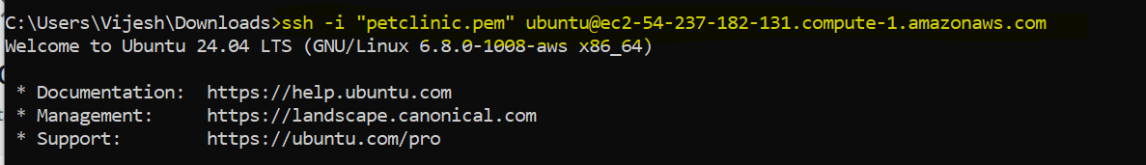

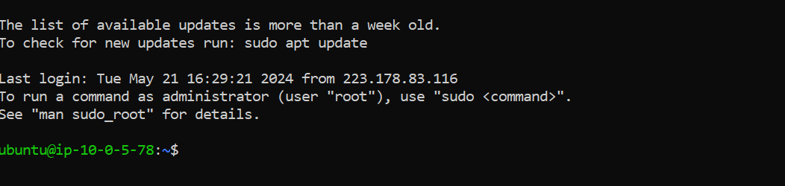

Now from here I will connect to the private instance any one:

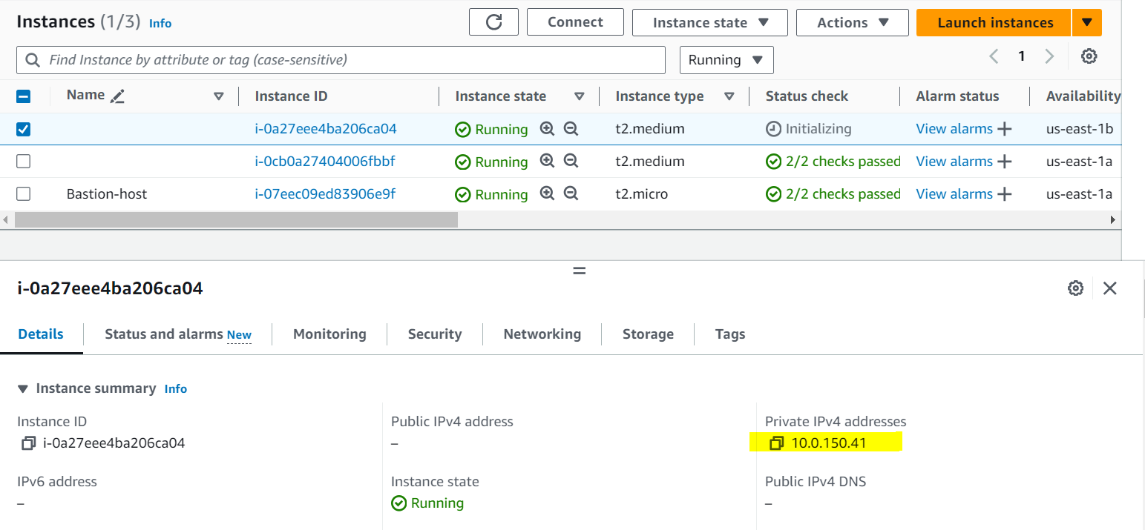

Make sure to copy the key file from the local system to the bastion-host:

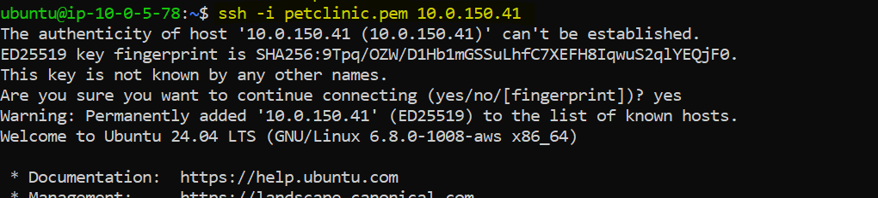

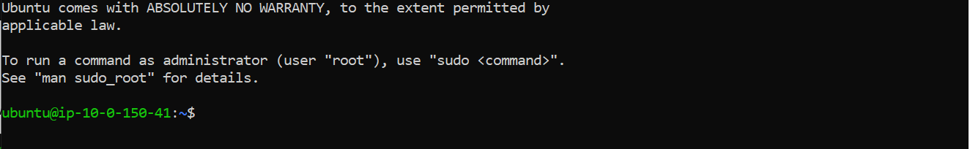

Now I am within the private instance , I will download a stress utility which increases the cpu usage:

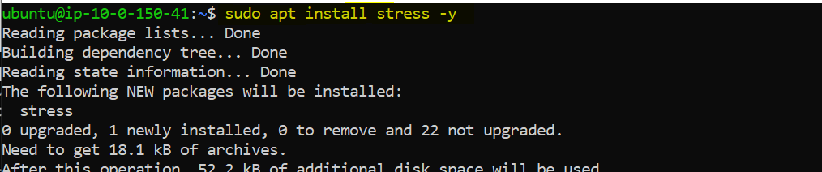



Now we will monitor the ASG CPU usage , once it crosses above 50 a new instance should be created.

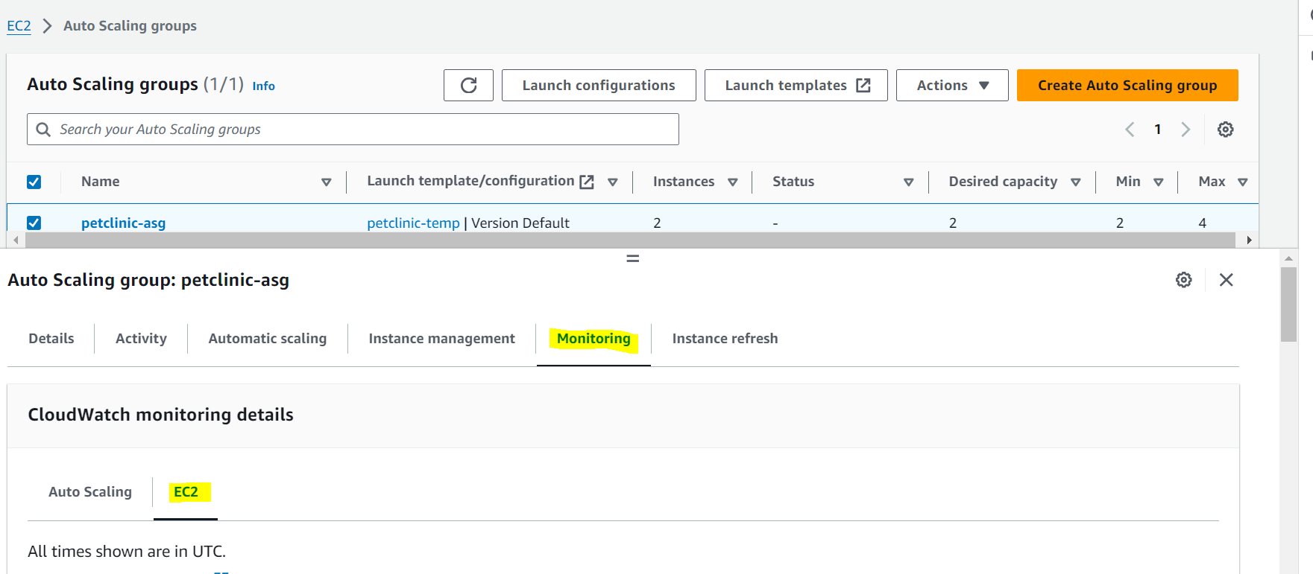

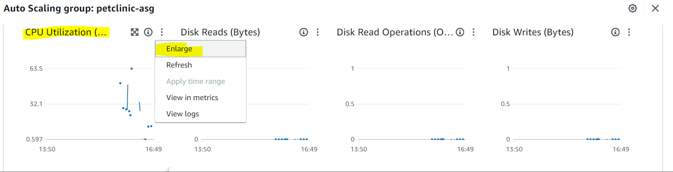

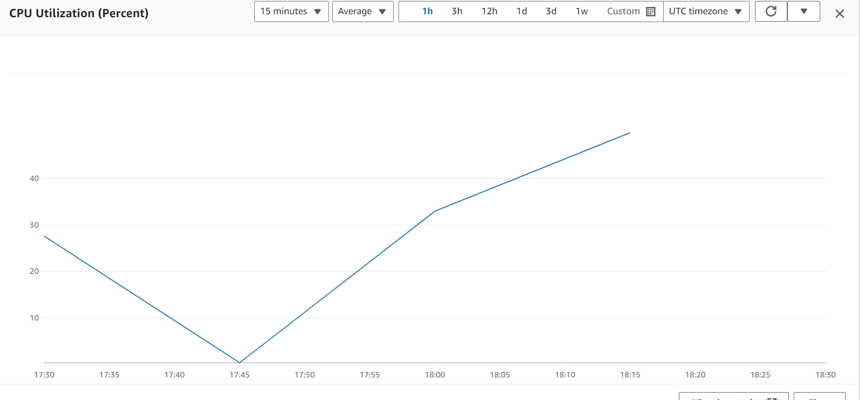

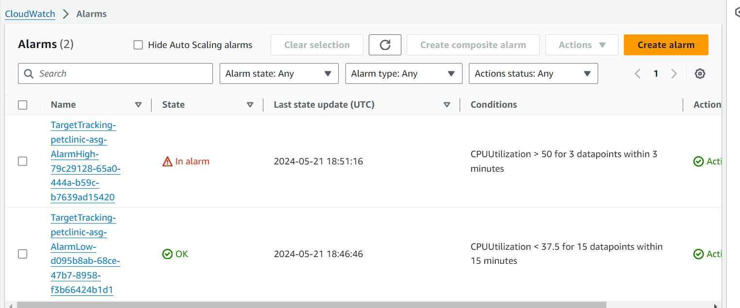

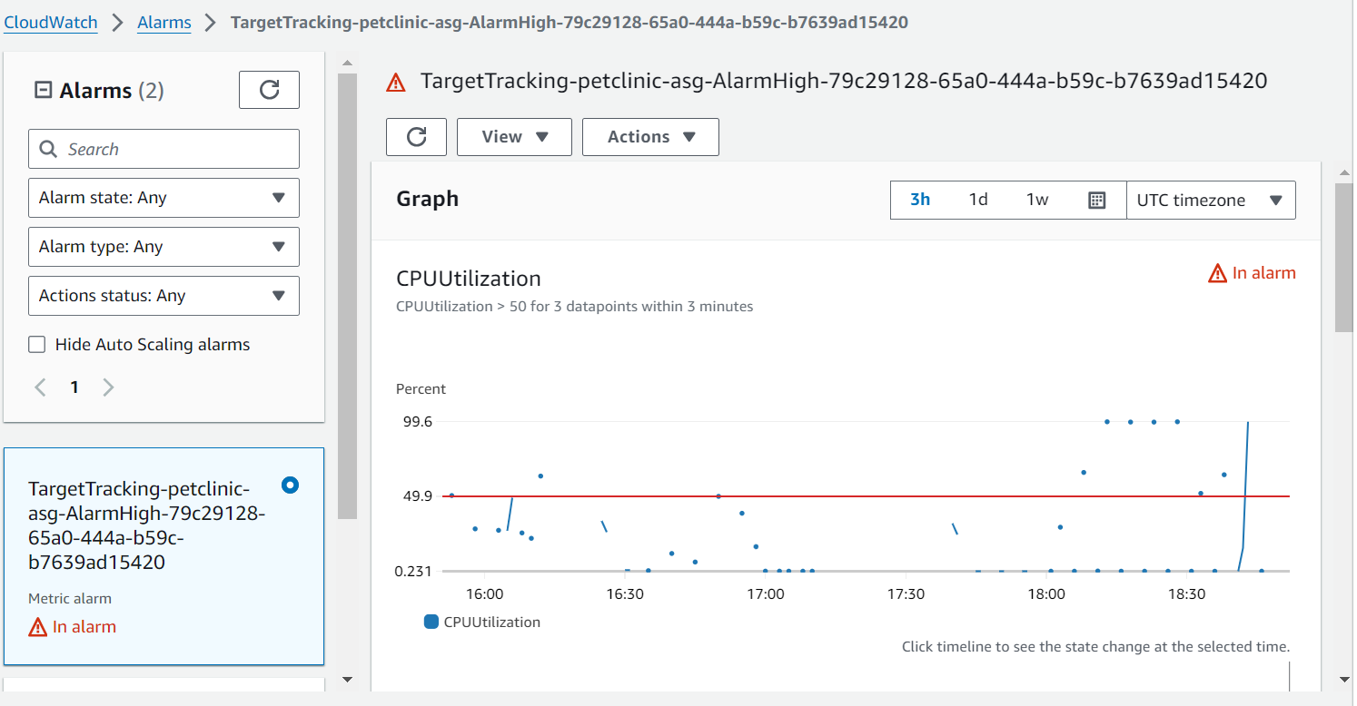

As the CPU crosses above 50 a new instance is created:

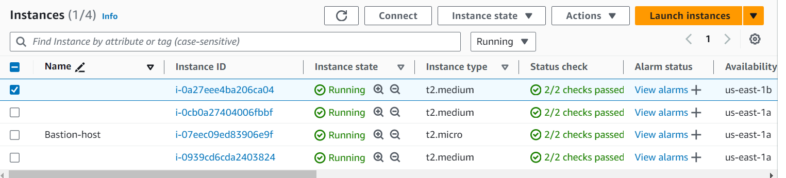

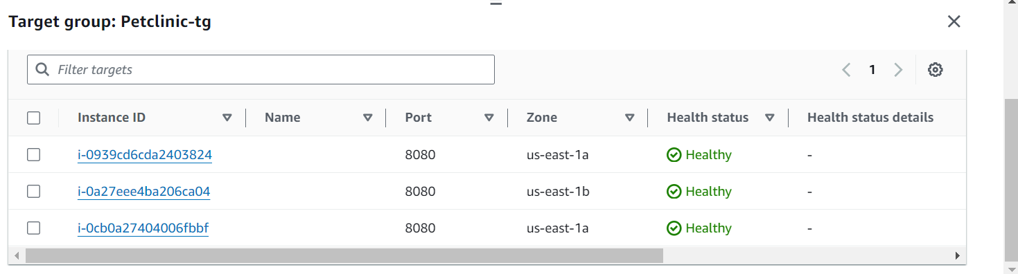

Again one more instance created since the stress utility is consuming more CPU, now there are total 4 instances:

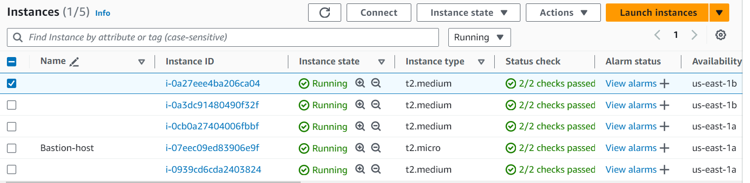

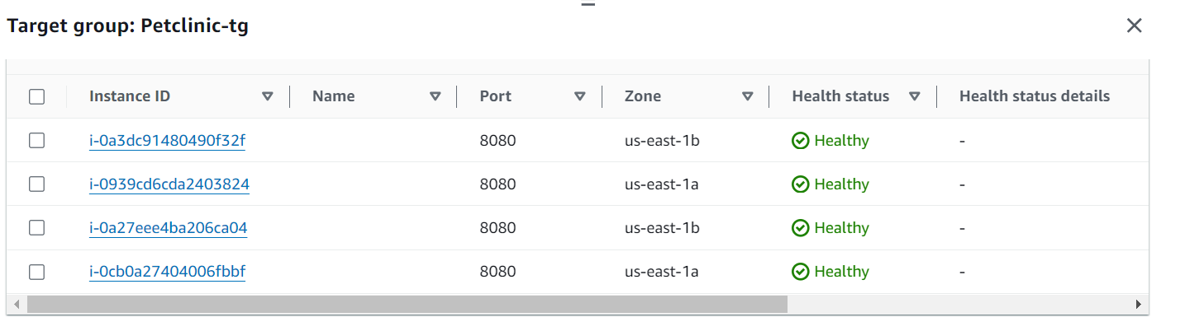

**Now we will stop the stress command to visualize the scale in:**

Press Ctrl+z to stop the stress command execution.

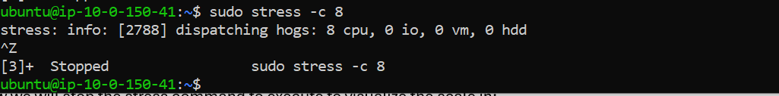

Now the in-alarm state of CPU high is changed to OK, now we have to wait around 15 min for the scale in alarm to trigger, since it is checking for CPU utilization for 15 mins:

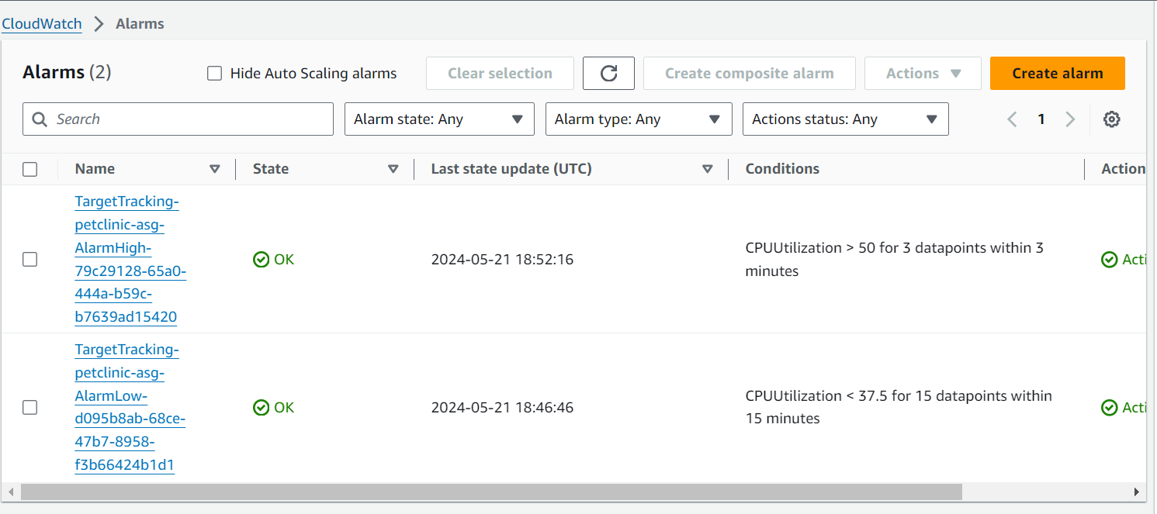

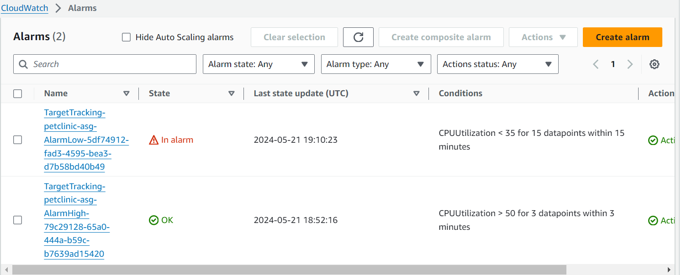

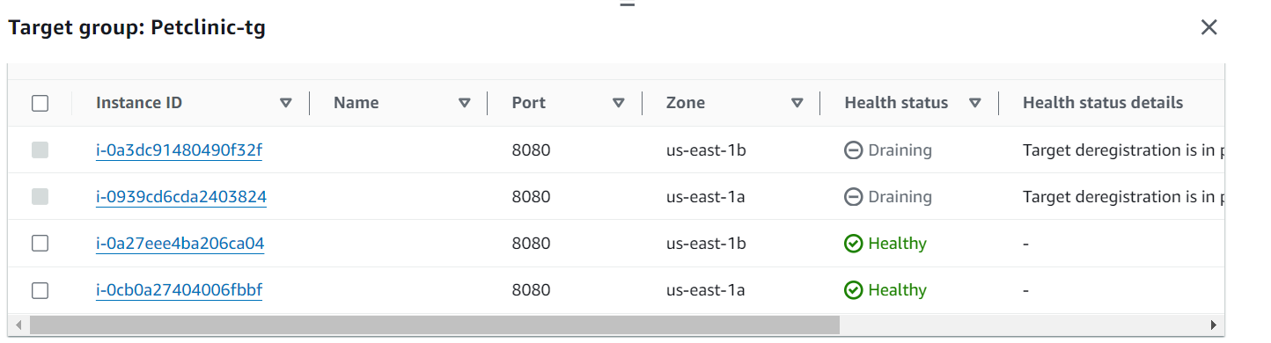

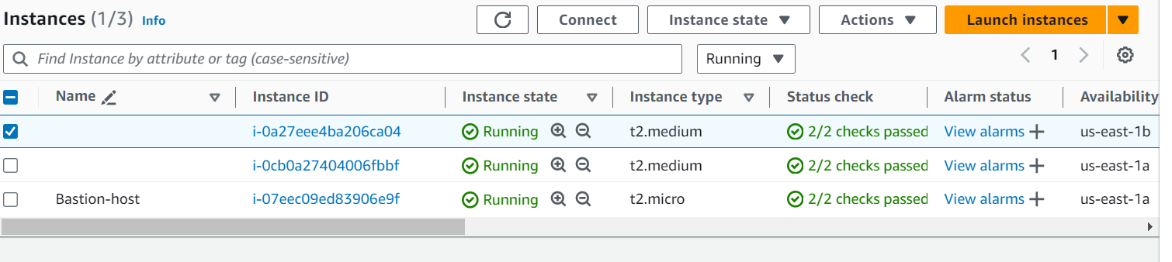

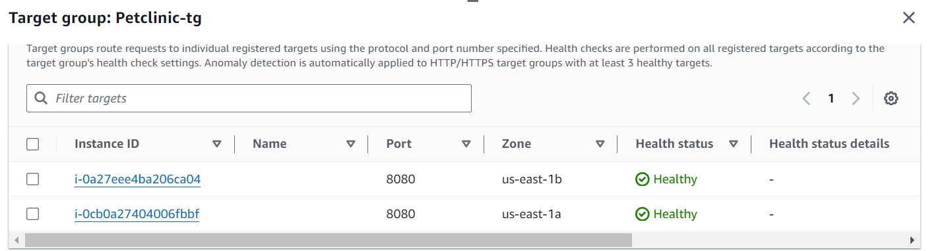

Now everything back to the desired state. Hence this finishes the practical.

**Troubleshooting steps in case of any issues:**

Make sure the instance type is t2.medium.

Make sure the port 8080 is open for the security group.

Make sure to increase the health check grace period to 500-600 seconds in order to start health check after the instance is initialized completely,

Make sure the unhealthy threshold is around 5 when creating target groups.

-----------------------------------------------------------------------------completed -----------------------------------------------------------------------------------------